Peppered Moths
Before the industrial revolution in Britain, most peppered moths were of the pale variety. This meant that they were camouflaged against the pale birch trees that they rest on. Moths with a mutant black colouring were easily spotted and eaten by birds. This gave the white variety an advantage, and they were more likely to survive to reproduce.
Airborne pollution in industrial areas blackened the birch tree bark with soot. This meant that the mutant black moths were now camouflaged, while the white variety became more vulnerable to predators. This gave the black variety an advantage, and they were more likely to survive and reproduce. Over time, the black peppered moths became far more numerous in urban areas than the pale variety.
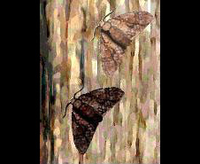
The pale peppered moths camouflage well against the pale birch tree
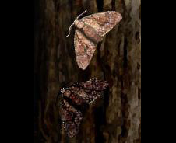
The darker mutant peppered moths camouflage well against the blackened birch tree

A story of change and transformation
The story of the Peppered Moth works on many levels. It reminds us that people can have a great impact on their environment and that there can be the possibility of change.

PEPPERED MOTH ART AND SCIENCE PROJECT and
Butterflies and moths in school
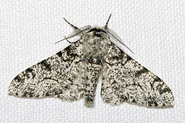
‘Whisper to a Shout’
The Peppered Moth story is a Manchester story, a story
of change. We want to use that story in creative ways,
incorporating Science and the Arts, and involving
people. We want to find ways to talk about and
think about positive futures for people and nature in
Manchester and the wider world.
Manchester School of Art, MMU
The Peppered Moth story has captured the attention of our whole School who have taken part in this project, Scientists helped the children catch moths to study, and they found out about habitats. The children also discovered facts about this interesting creature. The Manchester School of Art worked with groups of children and the staff in designing and making puppet moths and moth costumes. All staff also developed their own ideas and plans and delivered their own workshops to the children with particular skills in view. In addition, Artist, Emily Mott worked with the Key Stage 1 children to make the fabulous 3D artwork in our office Reception.
The children have also monitored the growth and metamorphosis of butterflies from caterpillars and examined the butterfly as a resurrection symbol.
Our Work
We hope that you will enjoy viewing our work, which ranges from chromatography, camouflage effects, cutting and stained glass to wire sculptures and costume design. You can also see some of our work on the School website.
Our Year 5/6 Art Club also enjoyed developing their sketchbooks on this theme.
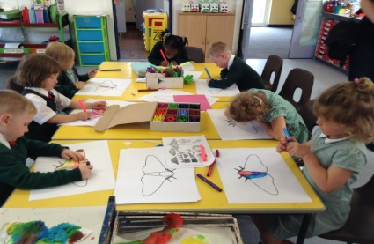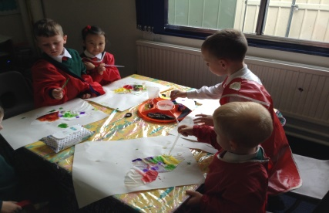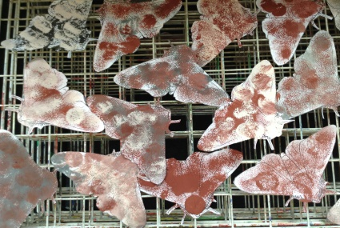
More Peppered Moth Activities

Alongside exploring the Peppered Moth’s story at Out of Schools, Manchester School of Art is working in partnership with Manchester Museum and Manchester Children’s Book Festival on a series of activities and events. These events will take place over 2016 as part of Manchester’s time as European City of Science, and will link to Manchester Museum’s ‘Climate Control’ exhibitions (May – Sept)..

