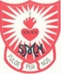
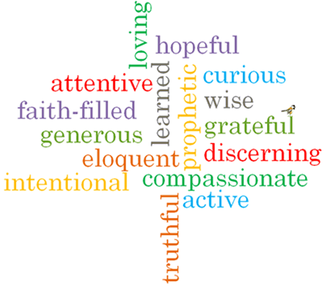
St Margaret Mary’s - Science Curriculum Overview 2023-24
 | Autumn 1 | Autumn 2 | Spring 1 | Spring 2 |  | Summer 1 | Summer 2
EYFS | All About Me – human body/senses | Space | How do things work?  Materials/forces | Animals |  | Healthy Eating | Minibeasts/Dinosaurs
Year 1 | Transition topic:  5 senses/ floating and sinking/forces | Seasonal Changes (2 lessons – Autumn)  Animals including Humans | Seasonal Changes (2 lessons Winter)  Everyday Materials | Seasonal Changes (2 lessons Spring)  Animals including Humans | Plants |  | Plants  Seasonal changes (Summer)
Year 2 | Animals including Humans | Uses of Everyday Materials | Animals including Humans | Plants |  |  | Living things and their habitats.
LSK2 | Rocks (3) | Light (3) | Electricity (4) | Animals including humans (Y3) |  | Living things and their habitats (4)
Year 5 | Forces | Earth and space | Changing states | Animals including humans |  | Living things and their habitats
Year 6 | Electricity | Light | Animals including humans | Evolution and inheritance |  |  | Living things and their habitats
Key dates:
4th – 10th October 2024 – Space Week
8th – 17th March 2024 – Science Week
11th June 2024 – Great Science Share

