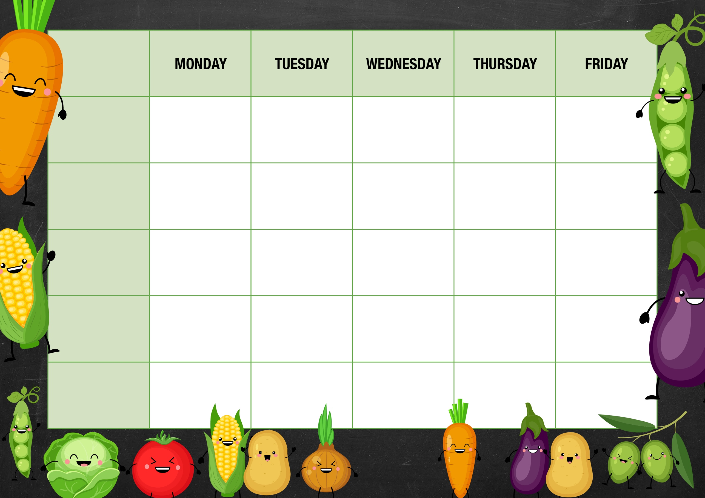

Roasted Winter vegetable pie served with seasonal vegetables and gravy

Nuggets and Wedges with garden peas and corn

**Week 1**

Baked Sausage seasonal potatoes

Garden Peas

Gravy

Burgers and Chips

Chilli con carne

Braised rice

Goan curry with coconut rice

Quorn sausage, mash and gravy

Veggie burgers and chips

Quorn nuggets with wedges, peas and corn

* Beans
* Cheese
* Tuna Mayo
* Chefs special
* Beans
* Cheese
* Tuna Mayo
* Chefs special
* Beans
* Cheese
* Tuna Mayo
* Chefs special
* Beans
* Cheese
* Tuna Mayo
* Chefs special
* Beans
* Cheese
* Tuna Mayo
* Chefs special

Sandwich selection served with unlimited salad from our continental salad bar

Sandwich selection served with unlimited salad from our continental salad bar

Sandwich selection served with unlimited salad from our continental salad bar

Sandwich selection served with unlimited salad from our continental salad bar

Sandwich selection served with unlimited salad from our continental salad bar

Chefs selection of homemade desserts, biscuits, fresh locally sourced fruit and yoghurts

Chefs selection of homemade desserts, biscuits, fresh locally sourced fruit and yoghurts

Chefs selection of homemade desserts, biscuits, fresh locally sourced fruit and yoghurts

Chefs selection of homemade desserts, biscuits, fresh locally sourced fruit and yoghurts

Chefs selection of homemade desserts, biscuits, fresh locally sourced fruit and yoghurts

**Chefs Special**

**Vegetarian Choice**

**Jacket Potato Bar**

**The Deli**

**Chefs Pantry**