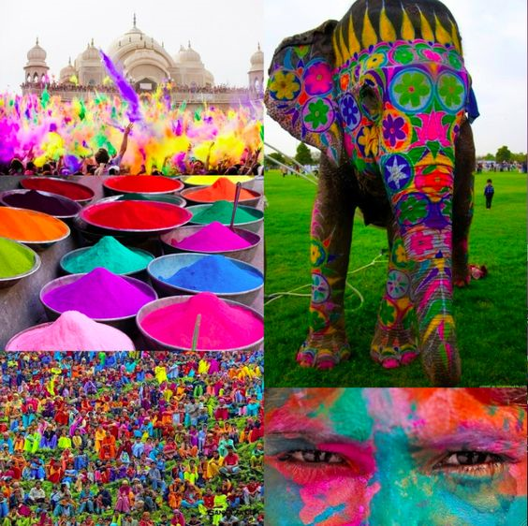

Vocabulary:

Texture

Material

Cut, stick

**Development Matters:**

Experiments to create different textures.

Understands that different media can be combined to create new effects.

Manipulates materials to achieve a planned effect.

**Texts:**

“Elmer the Elephant”

“The Blind Men and the Elephant”

Food Tasting

Malleable – clay

Coloured rice

Holi Festival

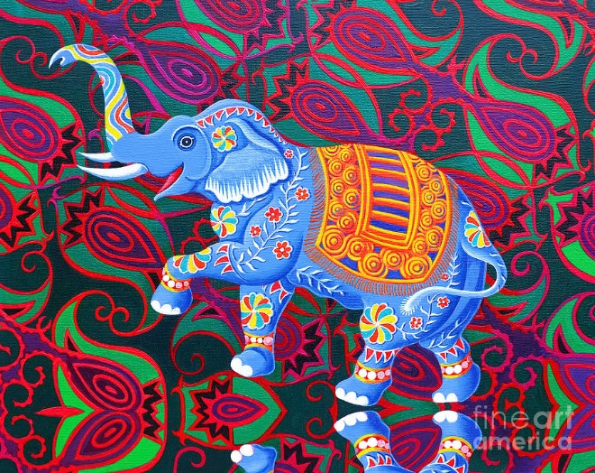

Indian elephant- Jane Tattersfield

Discussion on colours used and patterns e.g circles with bands, straight, round, pointy

Create patterns and copy them from the elephant

EXT: Look closely at the background of the painting and create a pattern using that

Make a textured panel for an Elmer Elephant.

Make individual elephants using different textures

Make a clay or salt dough elephant.

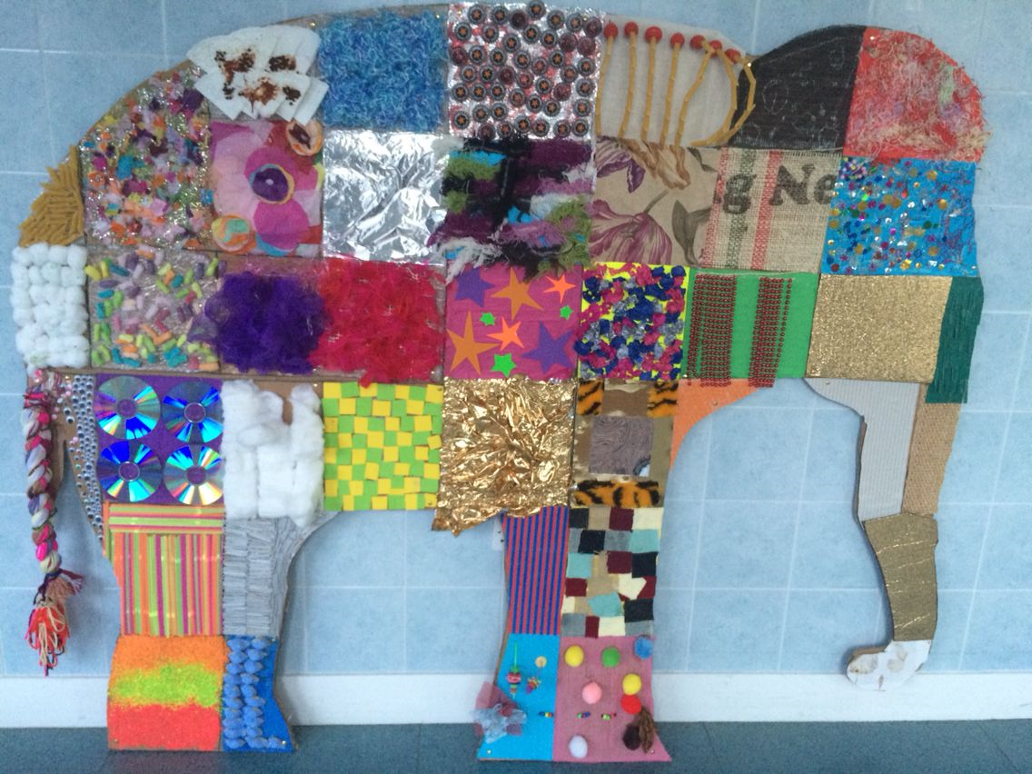

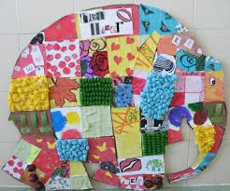

South East Asian Project – EYFS

Indian Elephants