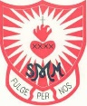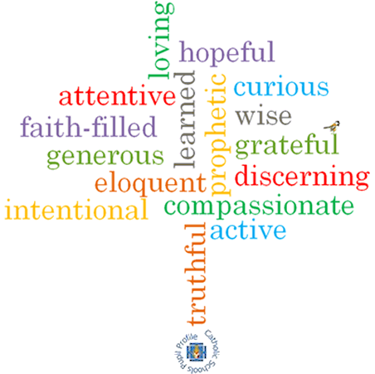#

**Topic: Family**

**Come and See Knowledge Organiser**

**Phase: EYFS**

**Strand: Domestic Church**

**What I will learn**

I will be able to **talk about** my own feelings.

I will **talk about** my experiences of being known and called by name.

I will be able to **recognise** some phrases from the Psalms which tell about God’s love for them.

**Vocabulary I will need to use**

God knows and loves each one

|  |  |
| --- | --- |
| Christian | Somebody who believes that Jesus Christ is God’s son and follows the example he sets for us. |
| First name | The name given to us by our parents that people use when they want to speak to us. |
| Family name | The name other people in our family might have in common. |
| precious | Something of great value that shouldn’t be wasted or treated badly. |
| parent | A person’s Mummy or Daddy. |
| God | God is the creator – the source of al life. God is our father. |
| love | A feeling we can experience. |
| loving | Feeling or showing love |
| prayer | An action where we speak to God. |

**Virtues**

**Scripture I will hear:**

Isaiah 43: 1-2 *God’s Story 1*

Psalm 131 *God’s Story 1*

**Big Question**

Why am I precious?

How do I know God loves me?

**What should I already know?**

Children will have experience of being part of a family.