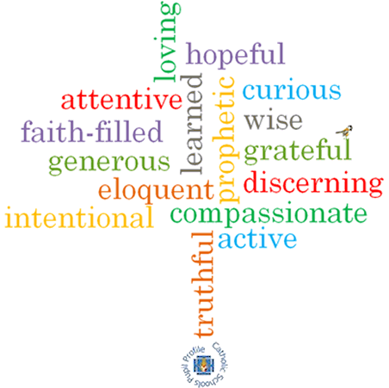

**Strand: Reconciliation**

**Topic: Friends**

**Come and See Knowledge Organiser**

**Phase: EYFS**

**Vocabulary I will need to use**

Friends of Jesus

|  |  |
| --- | --- |
| Jesus | The son of God. |
| Rule | Instructions on things we should or shouldn’t do. |
| Understanding | how we use what we know in our lives. |
| New start | A new beginning. |
| Friendship | The relationship between friends |
| Forgive | An action when somebody says sorry |
| change | When something different happens |

**Virtues**

**Scripture I will hear:**

Mark 6: 7, 30-32

John 13: 34

John 13: 34-35

**Big Questions**

Is it good to have friends?

Who are your friends?

Why are they your friends?

Are you anyone’s friend?

**What I will learn**

**Talk** about their experiences and feelings about what a friend is.

**Talk** about making friends and when friendships go wrong.

**Wonder** about what makes people friends.

**Recognise** that Christians show love for one another because Jesus asked them to do so. **Recognise** Jesus’ rule for friends and his words ‘love one another’.

**What should I already know?**

That everyone has good news, and that Pentecost is the celebration of the Good News of Jesus.