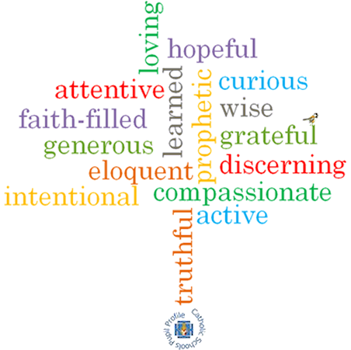

**Strand: Eucharist**

**Topic: Gathering**

**Come and See Knowledge Organiser**

**Phase: EYFS**

**Virtues**

**Scripture I will hear:**

Mark 10: 13,14,16

**Big Questions**

Why do people gather together?

What things are better done together?

Why are they better with others?

**Vocabulary I will need to use**

The parish family gathers to celebrate Eucharist

|  |  |
| --- | --- |
| Welcome | How we great someone in a friendly way. |
| Blessing | A feeling when you know God is taking care of you and protecting you. |
| Listen | Using our ears to hear other people. |
| Pray | An action where we talk to God. |
| Mass | When a Parish gathers together to praise Jesus. |
| Sing | An action we can do by ourselves or in a group, using our voice to make a sound, sometimes with music. |
| Gather | Coming together in one place. |
| Together | Being with a group of people |
| Alone | Being by yourself. |
| Lectern | A stand where the Bible is placed in Church for people to read from. |
| “The Lord be with you.” | Words said by the Priest in mass. |
| “And with your Spirit.” | What the Parish community say back to the priest when he says “The Lord be with you.”. |

**What I will learn**

I will begin to **talk** about the times I have gathered together with others. I will begin to **talk** about how they felt.

I will begin to say what I **wonder** about the enjoyment of being together.

I will begin to **recognise** the story of Jesus with the children as a religious story.

I will begin to **recognise** the phrases “The Lord be with you.” “And with your spirit.”

I will begin to **recognise** the Lectern and know how it is used.

I will begin to **recognise** how at Mass people gather to share the stories of God’s love.

I will begin to **talk about** their experience of visiting church and listening to God’s word.

**What should I already know?**

What a celebration is and that the parish family celebrates in church.