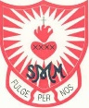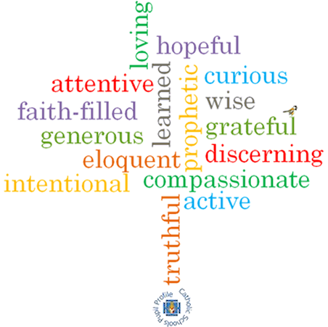

**Virtues**

**Scripture I will hear:**

Matthew 3: 13-17

John 13: 34-35

**Topic: Books**

**Strand: Local Church**

**Phase: KS1**

**Come and See Knowledge Organiser**

**Vocabulary I will need to use**

|  |  |
| --- | --- |
| Books |  |
| Library | A collection of books stored in one place. |
| Text book | A book that is usually used in schools and contains information. |
| Reverence | To show deep respect for someone or something. |
| Respect | A feeling of admiration for someone or something. |
| Scripture | Sacred writings. |
| lectern | A tall stand with a sloping top to hold a book. Used in Church to hold the Bible which is read from. |
| Gospel | The teaching of Christ told by Matthew, Mark, Luke and John. |
| Bible | Christian scripture made up of the Old and New Testament. |
| Old Testament | The first part of the Bible containing stories from the Prophets. |
| New Testament | The second part of the Bible containing the Gospels and other books with stories of Jesus’ life and teaching. |
| genre | A style or category of writing. |
| thurible | A vessel made of metal that is used to burn incense. |
| missal | A book containing the texts used in the Catholic Mass. |

**What I will learn**

**Talk** about their experience and feelings of books that are used at home and school.

Say what they **wonder** about the importance of books in their lives.

**Recognise** that the Bible is a special book and name some of the stories in the Bible.

**Recognise** and name some of the special books used in church and the people who use them.

**Ask and respond** to questions about their own and others’ experience and feeling of the different books that are used at home and school.

**Retell** the story of the Baptism of Jesus.

**Describe** how the Gospels are used by the parish family.

Use religious words and phrases to **describe** the actions and symbols related to proclaiming the Gospel.

**What should I already know?**

That on Sunday in Church, we meet people who do special jobs as we gather to celebrate the Good News of Jesus.

**Big Questions**

Why do we need books?

How many kinds of books do we use and why? What is special about the Bible and why it is important to us?