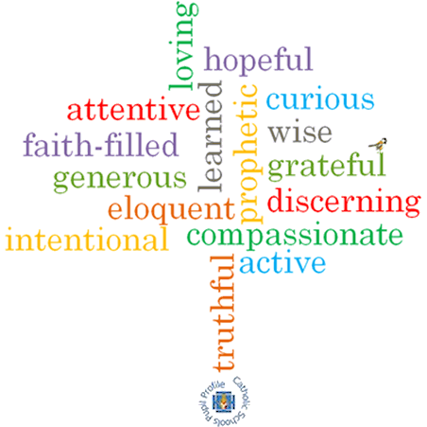

**Virtues**

**Scripture I will hear:**

John 15: 12

Colossians 3: 10-17

Matthew 18: 21-22

**Topic: Rules**

**Strand: Reconciliation**

**Phase: KS1**

**Come and See Knowledge Organiser**

**Vocabulary I will need to use**

|  |  |
| --- | --- |
| rules | Guidelines on things we should or should not do. |
| care | How we treat others. |
| safe | A feeling when we are away from any harm. |
| sorry | A feeling when we have done something wrong and we regret what we have done. |
| forgive | To stop feeling angry or resentful towards someone else. |
| right | Something that doesn’t break rules. |
| wrong | Actions that break the rules. |
| Make up | An action when we forgive somebody. |
| choices | Options we make. |
| sin | An action that breaks God’s laws. |
| consequences | What can happen as a result of our actions. |
| Examination of conscience | Reviewing our thoughts ad actions and what we have done wrong before we confess our sins. |

**What I will learn**

**Talk** about their own experience and feelings about rules in their life.

Say what they **wonder** about the importance of keeping rules for themselves and for others. **Recognise** the story of Peter asking Jesus about forgiveness as a religious story. **Recognise** some religious words and signs that Christians use to express sorrow and forgiveness. **Recognise** that people say sorry and ask forgiveness because they are followers of Jesus.

**Ask and respond** to questions about their own and others’ experiences and feelings of the importance of rules.

Use religious wordsand phrases to **describe** the examination of conscience. **Describe** some aspects of the Sacrament of Reconciliation. **Describe** how Christians try to practice Jesus’ commandment of love, peace and reconciliation.

**What should I already know?**

God helps us to choose well and to be sorry. God forgives us.

**Big Questions**

Why are rules important?

Why is it good to say sorry?