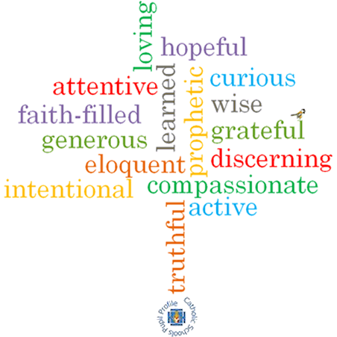

**Topic: Preparations**

**Strand: Advent/Christmas**

**Phase: KS1**

**Come and See Knowledge Organiser**

**Virtues**

**Scripture I will hear:**

Isaiah 9: 2, 6

Luke 1: 26-31, 38, 39-45

Luke 1: 45-55

Luke 2: 1-7

**Big Questions**

Why is it necessary to prepare?

**Vocabulary I will need to use**

|  |  |
| --- | --- |
| preparing | Actions we complete to get ready for an event. |
| Advent | The first season of the Church year, leading up to Christmas. It last for four weeks. |
| Christmas | A Christian festival celebrating the birth of Jesus Christ. |
| Nativity | The birth of Jesus Christ. |
| waiting | The time we spend preparing for something to happen. |
| Annunciation | The announcement made by the Angel Gabriel to Mary that she would have God’s son, Jesus Christ. |
| Visitation | The visit Mary made to her cousin Elizabeth. |

**What I will learn**

**Talk** about their own experience and feelings of preparing for special occasions.

**Say** what they wonder about the amount of time and care involved in preparing for Christmas.

**Recognise** the events around the birth of Jesus as religious stories.

**Recognise** some religious signs and symbols and use religious words and phrases connected with the liturgical season of Advent.

**Recognise** that Christians, through their actions follow Jesus as the Light of the World.

**Ask and respond** to their own and others, experience and feelings, about how important it is to prepare well and what happens if there is no preparation.

**Ask and respond** to questions about they and others **wonder** about the amount of time and care involved in preparing for Christmas and realise that some of these are difficult to answer.

**Retell** the stories of the Annunciation, the Visitation and the Nativity and be familiar with the characters in those events.

Use religious words and phrases to **describe** some religious actions and symbols connected with the liturgical season of Advent.

**Describe** how Christians follow Jesus as the Light of the World and live that out in their lives.

**What should I already know?**

That Advent is a time of waiting to celebrate Jesus’ coming at Christmas.