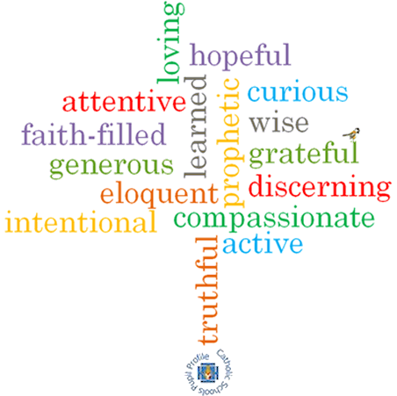

**Strand: Domestic Church**

**Phase: KS1**

**Topic: Beginnings**

**Come and See Knowledge Organiser**

**Virtues**

**Scripture I will hear:**

Genesis 1: 3, 9, 20, 24-26

Psalm 8: 3-11

Psalm 139: 14-18

Psalm 19: 1-5

Ephesians 1: 3-5

**Big Questions**

Where do I come from?

Why are some beginnings easy and some difficult?

Will there be many beginnings in my life?

**Vocabulary I will need to use**

|  |  |
| --- | --- |
| beginning | The start of something. |
| New start | When a new activity or event begins. |
| family | People who are related to one another. |
| friend | A person we have shared likes and experiences with. |
| creation | When an object I made. |
| psalm | A song or collection of verses with a religious theme, used in Christianity and Judaism. |
| litany | A series of prayers. |

**What I will learn**

**Talk** about their experience and feelings about new beginnings.

Say what they **wonder** about the excitement and surprise that a new start can bring.

**Recognise** the story of Creation as a religious story.

**Recognise** and use some religious words and phrases about types of prayer.

**Recognise** that people are kind and loving because God made them.

**Ask and respond** to questions about their own and others’ experiences about new beginnings.

**Ask questions** about what they and others wonder about the reasons for some beginnings being easy and others difficult and realise that some questions are difficult to answer.

**Retell** the story of Creation as a religious story or some phrases from the psalms.

**Describe** and use some religious words and phrases about types of prayer.

**Describe** that people are kind and loving because God made them.

**Ask questions** about what they wonder about the beauty around them and God creating the world.

**What should I already know?**

God’s love and care for every family.

Jesus was born and lived in a human family.