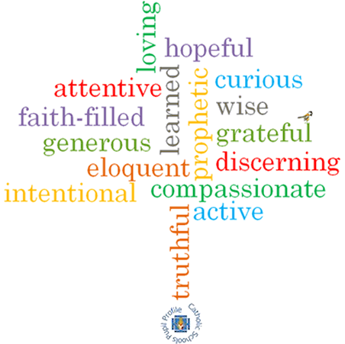

**Virtues**

**Scripture I will hear:**

Luke 22: 19-20

**Topic: Thanksgiving**

**Strand: Eucharist**

**Phase: KS1**

**Come and See Knowledge Organiser**

**Vocabulary I will need to use**

|  |  |
| --- | --- |
| Thank you | A polite phrase used to recognise how you feel when you receive something. |
| Thanksgiving | An expression of gratitude (being thankful) to God. |
| Thoughtful | Showing consideration for the needs of others. |
| Eucharist | The Catholic sacrament remembering the Last Supper in which bread and wine is turned into Jesus’ body & blood and eaten. |
| Eucharistic prayer | A prayer said during the mass. |
| liturgy | A form of worship. |

**What I will learn**

**Talk** about their experience of receiving and giving thanks.

Say what they **wonder about** how others feel when they are thanked.

**Recognise** the story of the Last Supper.

**Recognise** signs and symbols, different words and phrases used in the Eucharist (at Mass) to give thanks.

**Recognise** that Catholics go to Mass to remember what Jesus did at the Last Supper and give thanks to God.

**Ask and respond** to questionsabout how they and others feel when receiving and giving thanks.

**Retell** the story of the Last Supper.

Use words and phrases to **describe** some religious signs and symbols.

Use words and phrases to **describe** the steps involved in the Eucharist (Mass) showing how Catholics give thanks to God.

**Describe** how Catholics try to live what they have experienced at Mass in their daily lives.

**What should I already know?**

That the Mass is Jesus’ special meal.

**Big Questions**

Why it is important to say thank you?

How it feels to say thank you?

How it feels to be thanked?