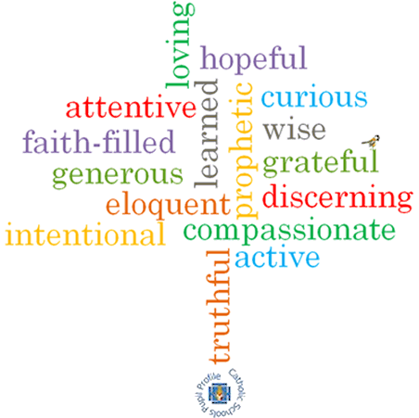

**Strand: Domestic Church**

**Phase: LKS2**

**Topic: Homes**

**Come and See Knowledge Organiser**

**What should I already know?**

God is present in every beginning

**Big Questions**

What does home mean to you?

How is God present in my life?

**Vocabulary I will need to use**

|  |  |
| --- | --- |
| Sorrows | A feeling of deep distress caused by loss, disappointment, or other misfortune. |
| Community | A group of people living in the same place or having a particular characteristic in common. |
| Family | A group of people who are related to each other. |
| Home | The place where a person lives, often with their family. |
| Love | Strong and warm affection between people. |
| Difference | What makes two or more persons or things not the same. |
| Respect | A way of treating or thinking about something or someone with kindness. |
| joys |  |

**What I will learn**

**Ask and respond** to questions about their own and others’ experiences and feelings about homes.

**Ask questions** about what they and others wonder about what makes a house a home and realise that sometimes this is a difficult question to answer.

**Retell** some of the advice offered by Paul in his letters about living together as a family and the life of the Holy Family.

**Describe** some ways Christians live as people chosen by God.

**Ask questions** about what they and others wonder about how God is always with us, and realise that this is a difficult question to answer.

**Make links** to show how feelings and beliefs affect how they, their behaviour and that of others in relation to the give and take of living in a family.

**Compare** their own and other people’s ideas about the difficult question of what make a house a home.

**Make links** between some scripture they have studied and the belief that God can make a difference in everyday life through God’s unchanging love.

**Give reasons** why Christians should try to love others.

**Compare** their own and others’ ideas about what they and others wonder about how God is always with us, and realise that some questions are difficult to answer.

**Scripture I will hear:**

Romans 12: 8-13

Ephesians 5: 1-9; and 6: 1-4.

Luke 2: 39-40

John 13:34-35

Col 3:12-17

**Virtues**