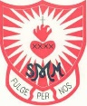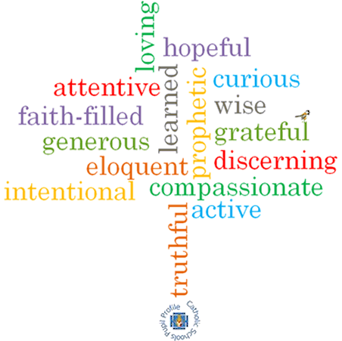

**Strand: Local Church**

**Phase: LKS2**

**Topic: Journeys**

**Come and See Knowledge Organiser**

**What should I already know?**

The books used in Church on Sunday by the parish family

**Big Questions**

How events mark the journey through the seasons of the year?

How we can help one another in life’s journey?

**Vocabulary I will need to use**

|  |  |
| --- | --- |
| Our Lady | Mother of Jesus, Mary. Also the mother of the catholic church. |
| Calendar | a chart or series of pages showing the days, weeks, and months of a particular year, or giving particular seasonal information |
| Season | each of the four divisions of the year spring, summer, autumn, and winter |
| Journey | a long and often difficult process of personal change and development |
| Liturgical | public worship |
| Feast day | a day on which a Christian celebration is held. |
| Ordinary time | The time in the church calendar that is not a feast day, celebration or a preparation for a celebration eg lent or advent. At this time the priest will wear green |
| feast day |  |

**What I will learn**

**Ask and respond** to questions about their own and others’ experiences and feelings about the events which mark the year or the season.   
**Ask questions** about what they and others wonder about how we help one another on the journey through the year.

**Retell** some of the stories of the Mysteries of the Rosary or the special feasts of the year.

Use religious words and phrases to **describe** the liturgical year and how it is composed of seasons and feasts days.

**Describe** how some prayer leads to good actions.

**Make links** to show how feelings and beliefs affect how they and others behave in their life journey and what is important to them.

**Make links** between some scripture and what Christians believe.

Use a developing religious vocabularyto begin to **give reasons** why Catholics celebrate certain feasts of the year and the reasons for the actions and symbols used.

**Scripture I will hear:**

Psalm 84

Psalm 118 – 19-20, 26-29

Psalm 122: 1-9

**Virtues**