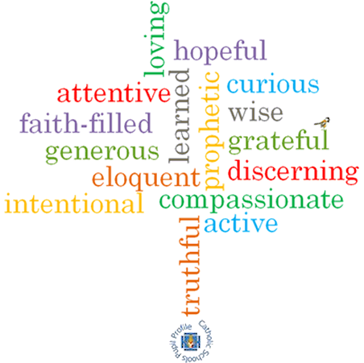

**Topic: Special Places**

**Strand: Universal Church**

**Phase: LKS2**

**Come and See Knowledge Organiser**

**What should I already know?**

**Big Questions**

Where is special for me?  
How do places become special?

**Vocabulary I will need to use**

|  |  |
| --- | --- |
| Pilgrim | A person who makes a special journey of spiritual and moral significance |
| Pilgrimage | A special place that reminds people how important it is to pray and take time to think about what is important in their lives |
| Universal Church | The Catholic Church and all the people within it |
| Temple | A temple is a building for spiritual or religious rituals |
|  |  |
| Nazareth | The place where Jesus grew up. This is in Israel. |
| Special | Better or greater from what is usual. Jesus is special in our lives. |
| Holy place | A place that is Holy and special to a religion |
|  |  |

**Scripture I will hear:**

Psalm 24:1

**Virtues**