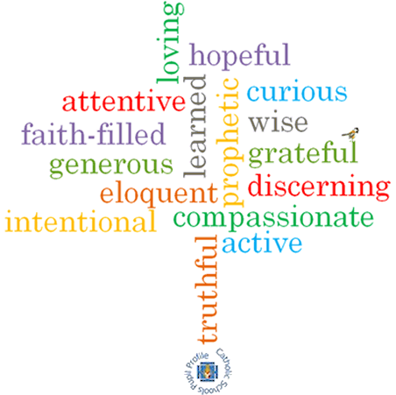

**Topic: Listening and sharing**

**Strand: Eucharist**

**Phase: LKS2**

**Come and See Knowledge Organiser**

**What should I already know?**

**The Eucharist:** the parish family thanks God for Jesus

**Big Questions**

What is so important about listening and sharing?

What is the cost of listening and sharing?

**Vocabulary I will need to use**

|  |  |
| --- | --- |
| Eucharist | A celebration consisting of 2 parts. The liturgy of the Word & the liturgy of the Eucharist. |
| Liturgy of the Word | Where Christians listen to God’s Word in the readings, listen to the homily and the prayers of the Faithful. |
| Liturgy of the Eucharist | Here the gifts are prepared, the Eucharistic prayer expresses thanksgiving and Communion is shared. |
| Holy Communion | 'togetherness.’ The taking of bread & wine. |
| Good News | Jesus loves us and died and rose for us |
| Ambo | A stationary podium used for readings and homilies |
| Listening |  |
| sharing |  |
| Mass |  |
| gathering |  |

**What I will learn**

**Ask and respond** to questions about their own and others’ experiences and feelings about listening well and sharing.

**Ask questions** about what they and others wonder about the joys and difficulties of listening and sharing and realise that some of these questions are difficult to answer.

Use religious words and phrases to **describe** the actions and symbols used during the celebration of the Eucharist.

**Describe** some ways in which Christians share God’s love with others.

**Make links** to show how feelings and beliefs affect their own and others’ desire to listen and to share.

**Compare** their own and others’ ideas about the questions of how and why we listen and share and that these questions are difficult to answer.

Use a developing religious vocabularyto **give reasons** for specific actions and words used during the celebration of the Eucharist.

Give **reasons** why Christians want to share the Good News of Jesus.

Give **reasons** why Christians want to share the Good News of Jesus.

**Scripture I will hear:**

2 Timothy 4:22

Liturgy of the Word – *Church’s Story 3* pages 56-57

Liturgy of the Eucharist – *Church’s Story 3* pages 58-63

**Virtues**