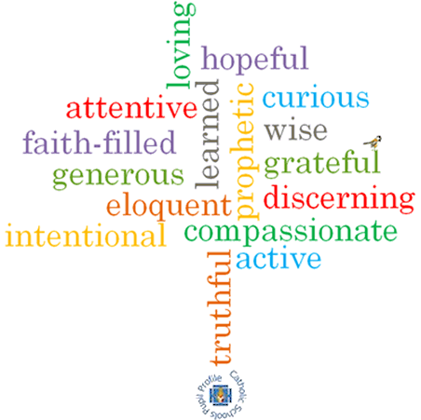

**Topic: Energy**

**Strand: Pentecost**

**Phase: LKS2**

**Come and See Knowledge Organiser**

**What should I already know?**

Pentecost, spreading the Gospel message through the gift of the Holy Spirit.

**Big Questions**

How can the energy of the wind be used for good?

How the Holy Spirit inspires Christians?

**Vocabulary I will need to use**

|  |  |
| --- | --- |
| Fire | The heat, light, and flames produced by burning. |
| Holy Spirit | The third person of the Trinity; God as spiritually active in the world. |
| Energy | The power by something. |
| Power | The feeling of strength. |
| Rosary | A prescribed series of prayers recited by Roman Catholics to the Virgin Mary. |
| Glorious Mysteries | The part of Jesus’ life after he died. He ascended into Heaven, the Holy Spirit came to the Apostle’s and Mary’s Death. |
| Pentecost | A Christian festival on the seventh Sunday after Easter, celebrating the descent of the Holy Spirit on the Apostles of Jesus Christ. |
| warmth |  |
| wind |  |
| gifts |  |

**What I will learn**

**Ask and respond** to questions about their own and others’ experiences and feelings about the power of fire and wind and how this energy can be used for good.

**Ask questions** about what they and others’ wonder about the power of wind and fire and realise that some of these questions are difficult to answer.

**Retell** the story of the Ascension and the coming of the Holy Spirit at Pentecost.

Use religious words and phrases to **describe** what happened to the apostles at Pentecost, what they saw and felt.

**Describe** some ways in which Christians live when they use the energy and gifts of the Holy Spirit.

**Compare** their own and other people’s ideas about questions that are difficult to answer about the best use of the power of wind and fire.

**Make links** between the Pentecost story and Christian belief in the power of the Holy Spirit.

**Give reasons** for the love Christians show because they are inspired by the Holy Spirit.

**Scripture I will hear:**

Matthew 28: 1-10

John 16: 5-7

1 Corinthians 12: 4-8, 11

Acts 1: 6-11

Acts 2: 1-18, 43,

Isaiah 11: 2

**Virtues**