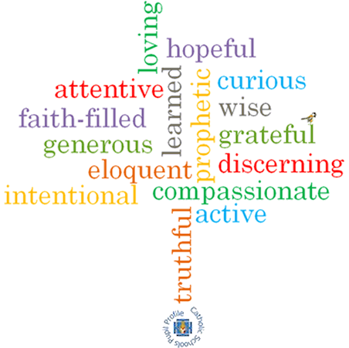

**Strand: Domestic Church**

**Phase: LKS2**

**Topic: People**

**Come and See Knowledge Organiser**

**What should I already know?**

God’s vision for every family.

**Big Questions**

Where do I come from?

To whom do I belong?

To which family did Jesus belong?

**Vocabulary I will need to use**

|  |  |
| --- | --- |
| Chosen people |  |
| Siblings | Brothers and sisters |
| Relations | Members of your family |
| Ancestors | People we are descending from. |
| Generations | People born and living at the same time. |
| Old Testament | The part of the Bible written before Jesus was born. |
| Roots | The base of a family tree. |
| Family tree | A map of who is part of a family and who we are related to. |
| Genealogy | The study of family history. |
| Nomad | A member of people that travels from place to place. |
| nomadic | Living the life of a nomad; wandering. |

**Scripture I will hear:**

Matthew 1: 1-17

Mt 2: 13-15, 19-23,

Lk 2: 40-51,

Mk 1: 14-20

Genesis 12: 1-8, 18

Genesis 21: 1-7

Genesis 25: 20-27

Genesis 35: 9-15, 23-26

Ruth 1: 2-7, 16, 17

1 Kings 1, 2, 4

**What I will learn**

**Compare** their own and others’ ideas about the questions that family trees raise and are difficult to answer.

**Make links** between these stories and what people believe about God and Jesus.

**Give reasons** for certain actions by believers such as Ruth.

**Describe and show understanding** of the roots of Jesus’ human family.

**Describe and show understanding** of what Christians believe about how God leads and guides people.

**Virtues**