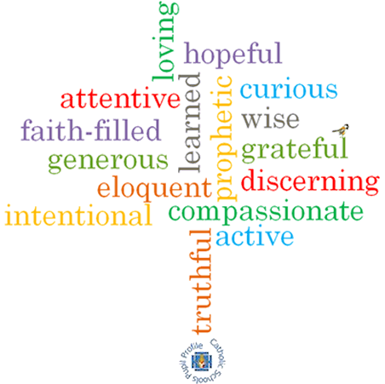

**Topic: Community**

**Strand: Local Church**

**Phase: LKS2**

**Come and See Knowledge Organiser**

**What should I already know?**

The Christian family’s journey with Jesus through the Church’s year.

**Big Questions**

Why do people give up their time to help others in the community?

What makes communities function well for the good of others?

**Vocabulary I will need to use**

|  |  |
| --- | --- |
| Community | A group of people living in the same area or having something in common. |
| Commitment | The state or quality of being dedicated to a cause or activity. |
| Responsibility | The state or fact of having a duty to deal with something or having control over something or someone. |
| Parish | A small district or area typically with its own church and priest. |
| Laity | Members of a parish who are not ordained – the ordinary people. |
| Ministries | The work or vocation of a minister of religion. |
| Extraordinary Ministers | A member of the laity who has been given special permission to distribute the Holy Eucharist. |
| service | An act of worship. |
| Funeral rites | Practices followed by the Catholic church at a funeral service. |
| Pastoral area | A cluster of neighbouring parishes that work together. |
| deanery | Parishes assembled in smaller geographical groups, working under the care of a ‘dean’. |

**What I will learn**

**Ask and respond** to questions about their own and others’ experiences of being part of a community.

**Ask questions** about what they and other wonder about the responsibility and commitment of belonging to a community.

**Retell** the story of the call of the apostles.

Some children will be able to **describe** some of the advice St. Paul gives us about being loving members of a community.

Use religious words and phrases to **describe** the actions and symbols within a funeral Mass.

D**escribe** some ways in which some people serve their parish community.

**Make links** to show how feelings and beliefs affect their commitment to community and that of others.

**Make links** between the call of the apostles and God’s call to people to serve him today.

Use a developing religious vocabularyto **give reasons** for the actions and symbols used within a funeral Mass.

Some children will be able to **give** **reasons** why people give service to the parish community through various ministries.

**Virtues**

**Scripture I will hear:**

Romans 12: 8-11

Mark 3: 13-19

Acts 6: 2-13; 7: 57-60