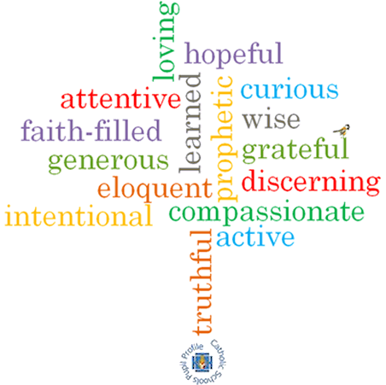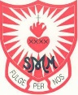

**Strand: Baptism/Confirmation**

**Phase: LKS2**

**Topic: Called**

**Come and See Knowledge Organiser**

**What should I already know?**

The meaning of the promises made at Baptism.

**Big Questions**

How does it feel to be chosen?

How do people respond to being called?

**Vocabulary I will need to use**

|  |  |
| --- | --- |
| Chosen | To be selected |
| Response | An answer |
| Sacrament of Confirmation | One of the sacraments of initiation |
| Oil of Chrism | A special oil used during Baptism and Confirmation. |
| Mitre | A headdress warn by a Bishop. |
| Crozier | A hooked staff carried by a Bishop as a symbol of pastoral office. |
| Sponsor | A person who provides support for an individual. |
| Catechist | A teacher of the principles of Christianity. |
| Bishop | A senior member of the clergy, in charge of priests and deacons. |
| Holy Spirit | God as spiritually active in the world. |
| witness | A person who has seen an event occur. |
| anointing | To smear or rub with oil as part of a sacrament. |
| Holy Trinity | God in three parts; God the Father, God the Son and God the Holy Spirit. |
| enkindle | To inspire or arouse emotion. |
| called | To be asked by name to do something. |

**What I will learn**

**Ask and respond** to questions about being chosen.

**Ask questions** about what they and others wonder about the reason for responses to being chosen.

**Retell** some special stories about religious events and people such as David and/ or the call of the apostles.

Use religious words and phrases to **describe** what it means to be called.

D**escribe** some ways in which people are called to live a Christian life.

**Make links** between scripture and the call to holiness.

**Make links** to show how feelings and beliefs can affect the responses they might make to being chosen.

Use a **developing religious vocabulary** to **give reasons** for the actions and symbols used at Confirmation.

**Give reasons** why and how Christians respond to God ‘s call.

**Scripture I will hear:**

Samuel 2: 11, 3: 3-10, 19

Samuel 16: 4-13

Corinthians 12: 31: 13: 1-8,

Mark 1: 14-20

John 1: 5-7

**Virtues**