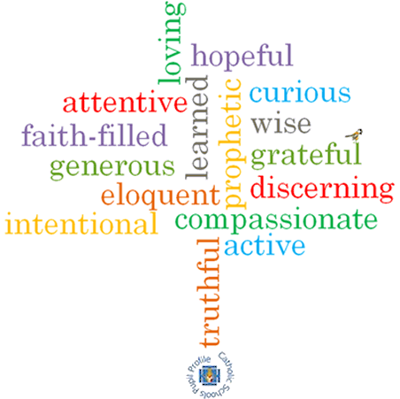

**Topic: New Life**

**Strand: Pentecost**

**Phase: LKS2**

**Come and See Knowledge Organiser**

**What should I already know?**

The wonder and power of the Holy Spirit.

**Big Questions**

How can good news change the way you feel?

How good news can bring life?

**Vocabulary I will need to use**

|  |  |
| --- | --- |
| Life | The state of existence. |
| Good News | The positive news of Jesus and God. |
| Resurrection | The rising from the dead of Jesus Christ. |
| Pentecost | A Christian festival celebrating the descent of the Holy Spirit on the disciples of Jesus after his ascension. |
| Holy Spirit | The spirit form of God. |
| fellowship | Friendly association, especially with people who share one’s interests. |

**What I will learn**

**Ask and respond** to questions about their own and others’ experiences of good news bringing life.

Ask questions about what they and others **wonder** about how good news brings life and happiness.

**Retell** some special stories about the religious events and people connected with Pentecost.

Use religious words and phrases to **describe** the events of Pentecost.

**Describe** some ways in which the apostles spread the Good News through the power of the Holy Spirit.

**Make links** to show how feelings of sadness and joy and the belief in the goodness of others, affects their own and others’ behaviour.

**Compare** their own and other people’s ideas about how good news brings life.

**Give reasons** why the apostles spread the Good News and the reasons for the actions of Peter, John and Paul.

**Make links** between the Pentecost story and the Christian belief in the new life of the Easter message through the power of the Holy Spirit.

**Virtues**

**Scripture I will hear:**

Acts 4 : 1-26

2 Corinthians 6: 3-10

Acts 8: 26-30, 34-38