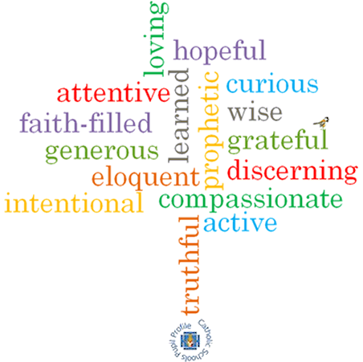

**Topic: Giving & receiving**

**Strand: Eucharist**

**Phase: LKS2**

**Come and See Knowledge Organiser**

**What should I already know?**

That during mass we listen to the word of God and share in Holy Communion.

**Big Questions**

Why is giving important as well as receiving?

What are the joys and demands of giving and receiving? Why is giving and receiving important in any group?

Why is it important to live in communion?

**Vocabulary I will need to use**

|  |  |
| --- | --- |
| Communion | The part of the mass where bread and wine are consecrated & shared as a meal. |
| Community | A group of people living in the same place or having a particular characteristic in common. |
| Giving | Providing love or other emotional support. |
| Receiving | To take into your possession. |
| Liturgy of the word | The second part of the mass during which the faithful are instructed in the revealed word of God. |
| Penitential Act | The invitation by the priest at Mass for the congregation to acknowledge their sinfulness. |
| Lamb of God | One of the names given to Jesus Christ. |
| Concluding rite | The end of the mass where blessings are given and the congregation are asked to go out and spread the word of God. |
| Sign of peace | The part of the mass where members of the congregation share a sign of peace, usually a handshake. |
| Introductory rite | The beginning part of the mass where a community is formed to worship God. |
| Eucharist | The Catholic sacrament commemorating the Last Supper in which bread and wine are consecrated and shared. |
| Communion rite | The celebration of the Eucharist as a meal, made up of 6 parts. |

**What I will learn**

**Ask and respond** to their own and others’ experiences and feelings about giving and receiving.

**Ask questions** about what they and others wonder about giving and receiving every day.

**Describe** what happens during the Introductory Rite.

**Describe** what a person might do if they follow Jesus’ advice.

**Describe** ways in which peace is lived out by believers.

**Make links** to show how feelings and beliefs about giving and receiving affects their own behaviour and that of others.

**Compare** their own and other people’s ideas about questions of giving and receiving.

**Make links** between scripture and an understanding of the Eucharist.

Use a developing religious vocabularyto **give reasons** for religious actions and symbols used in the celebration of the Eucharist.

**Give** **reasons** why Christians attend the celebration of the Eucharist.

**Virtues**

**Scripture I will hear:**

Matthew 5: 45-48

1 Corinthians 11: 24-27

Romans 12: 8-11