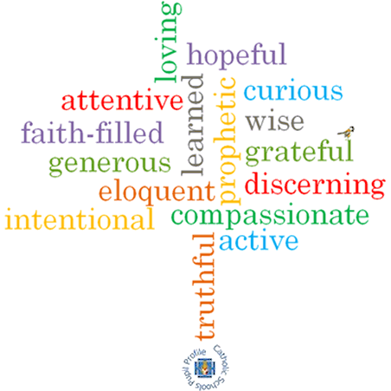

**Topic: Freedom and Responsibility**

**Strand: Reconciliation**

**Phase: UKS2**

**Come and See Knowledge Organiser**

**What should I already know?**

The importance of admitting wrong and being reconciled with God and each other

**Big Questions**

How to enjoy freedom with responsibility?

How rules can bring freedom?

**Vocabulary I will need to use**

|  |  |
| --- | --- |
| freedom |  |
| responsibility |  |
| Beatitudes, |  |
| Commandments |  |
|  |  |
|  |  |
|  |  |

**Scripture I will hear:**

Exodus 20: 1-17

Deuteronomy 6: 4-9

Isaiah 58: 3-8

Amos 5: 14-15

Mark 12: 28-31

Matthew 5: 1-17

**What I will learn**

**Make links** to show how feelings and beliefs about the relationship of freedom and responsibility affect their behaviour and that of others. **Compare** their own and other people’s ideas about questions concerning the use of freedom and responsibility and know that these questions are sometimes difficult to answer. **Make links** between the stories of the Ten Commandments, the Beatitudes and other texts studied and belief in God’s rules for living freely and the responsibility this brings. **Give reasons** why believers choose to live by God’s laws.

**Make links** to show how feelings and beliefs in the laws God has given us affect their behaviour and that of others.

**Engage and respond** to questions of life in the light of religious teaching on the freedom and responsibility given to us by God through his laws.

**Show** how their own and others’ decisions about freedom and responsibility are informed by beliefs and values.

**Describe and show understanding** of scripture, beliefs, ideas, feelings and experiences of living according to God given laws and how when we fail to keep these laws and are contrite we can be reconciled with God and with others. **Show understanding** of how religious belief in the freedom and responsibility of living by God’s law shapes our lives.

**Virtues**