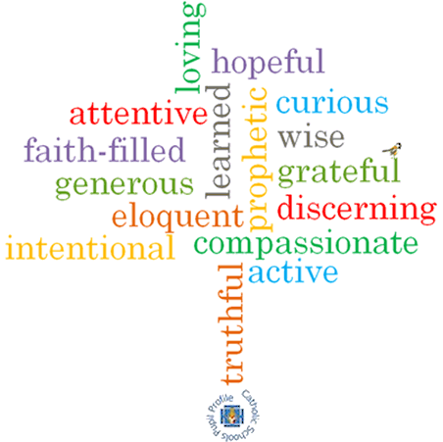

**Topic: Stewardship**

**Strand: Universal Church**

**Phase: UKS2**

**Come and See Knowledge Organiser**

**What should I already know?**

**Big Questions**

**Vocabulary I will need to use**

|  |  |
| --- | --- |
|  |  |
|  |  |
|  |  |
|  |  |
|  |  |
|  |  |
|  |  |
|  |  |

**Scripture I will hear:**

**What I will learn**

**Virtues**