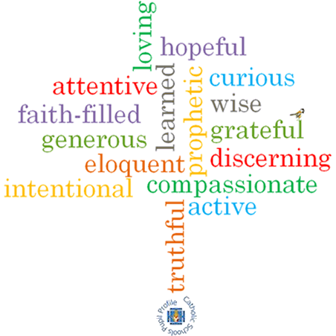

**Topic: Common good**

**Strand: Universal Church**

**Phase: UKS2**

**Come and See Knowledge Organiser**

**What should I already know?**

Members of the Church are called to be stewards of creation.

**Big Questions**

How can we work together to build a just and fair world?

**Vocabulary I will need to use**

|  |  |
| --- | --- |
| Justice | Just behaviour or treatment. |
| Injustice | Lack of fairness or justice. |
| Respect | A feeling of deep admiration for someone or something. |
| Solidarity | Unity or agreement of feeling or action. |
| Difference | A point or way in which people or things are dissimilar. |
| Social justice | Justice in terms of the distribution of wealth, opportunities & privileges within a society. |
| Common good | For the benefit or interests of all. |
| dignity | The state or quality of being worthy of honour and respect. |
| Catholic Social Teaching | Guiding principles of the Catholic Church rooted in scripture. It is our moral compass guiding us on how to live out our faith in the world. Made up of seven principles. |

**What I will learn**

**Make links** to show how their feelings and beliefs about being treated fairly/unfairly, justly/unjustly affect their behaviour and that of others and be able to **compare** their own and other people’s ideas and questions.

**Make links** between Micah, Matthew 25, the Beatitudes and beliefs and **give reasons** for certain actions by believers, in working for justice and the common good.

**Show how** their own and other’s decisions to act justly and fairly/unjustly and unfairly are informed by beliefs and values and be able to **describe and show understanding** of religious sources, beliefs, ideas, feelings and experiences around the common good, making links between them.

**Show understanding** of how religious belief in justice and of the common good of all shapes life and be able to **engage with and respond to** big questions around justice and the common good in the light of religious teaching.

**Explain** what beliefs and values inspire and influence them and others to act justly and fairly and be able to **identify** sources of religious belief and explain how religious beliefs including Catholic Social Teaching about the common good arise.

**Demonstrate** how religious beliefs and Catholic Social Teaching give some explanation of the purpose and meaning of life.

**Virtues**

**Scripture I will hear:**