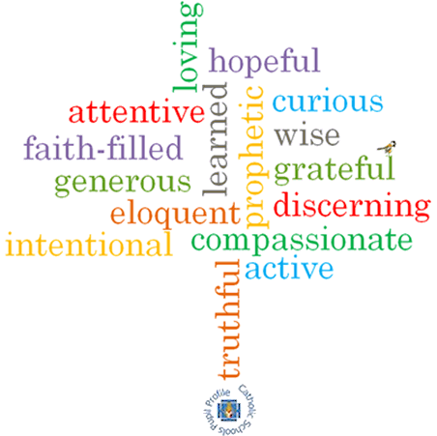

**Topic: Unity**

**Strand: Eucharist**

**Phase: UKS2**

**Come and See Knowledge Organiser**

**What should I already know?**

The Eucharist keeps the memory of Jesus’ sacrifice alive and present in a special way.

**Big Questions**

What helps friendships to grow?

What makes unity between people?

What undermines friendship and unity?

**Vocabulary I will need to use**

|  |  |
| --- | --- |
| Eucharist | The Christian sacrament commemorating the Last Supper, in which bread and wine are consecrated and consumed. |
| Communion | The service of Christian worship at which bread and wine are consecrated and shared. |
| Community | A group f people living in the same place or having a particular characteristic in common. |
| Unity | The state of being united or joined as a whole. |
| Friendship | The emotions or conduct of friends; the state of being friends. |
| nourish | Provide with the food or other substances necessary for growth, health and good condition. |

**What I will learn?**

**Make links** to show how feelings and beliefs about what makes, and breaks friendship and unity affects their behaviour and that of others.

**Ask and respond** to questions about their own and others’ experiences and feelings about friendship and unity.

**Compare** their own and other people’s ideas about questions concerning friendship.

**Make links** between scripture and the Eucharist.

Use a developing religious vocabularyto **give reasons** for the actions and symbols of the Communion Rite.

**Give** **reasons** why Christians gather together in ‘communion’ and receive ‘Holy Communion’.

**Show how** their own and others’ decisions about friendships are informed by beliefs and values.

**Show understanding** of the links between a range of Scripture texts and some parts of the Mass which express communion with Jesus and the feelings that communion with others brings.

Use religious termsto **show an understanding** of different aspects of the Eucharist.

**Show understanding** of how belief in Jesus Christ, the uniting presence in Holy Communion, shapes the lives of Christians.

**Virtues**

**Scripture I will hear:**

Matthew 6: 9-15

John 17: 11, 20-23

Romans 12: 3-10

1 Corinthians 10:17

1 Corinthians 12:12-13