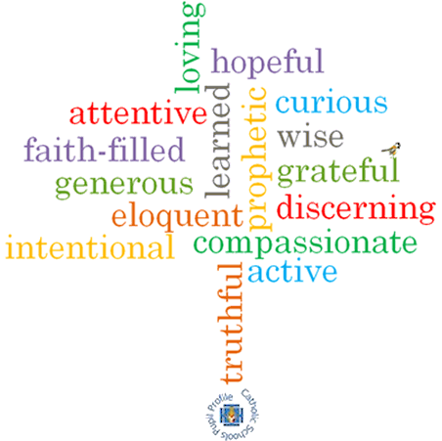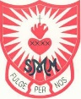

**Topic: Vocation & Commitment**

**Strand: Baptism/Confirmation**

**Phase: UKS2**

**Come and See Knowledge Organiser**

**What should I already know?**

The call to life and love within the community and the sacrament of marriage.

**Big Questions**

What does it mean to be committed?

Why are some people so dedicated to the service of others?

**Vocabulary I will need to use**

|  |  |
| --- | --- |
| commitment | Dedication to something. |
| dedicated | Devoted to a task or purpose. |
| vocation | A strong feeling of suitability for a particular career. |
| Ordination | The action of ordaining someone in Holy orders. |
| anointing | To smear or rub with oil as part of a religious ceremony. |
| Religious life | A state of life in the Catholic Church, lived by believers who wish to follow Jesus Christ in a more exacting way. |
| service | The action of helping or doing work for someone. |
| celibacy | The state of abstaining from marriage or relations with another person. |
| vows | a solemn promise |

**What I will learn**

**Make links** to show how feelings and beliefs affect behaviour in relation to commitment.

Using a **developing religious vocabulary**, to **give reasons** for the signs and symbols used in the Sacrament of Holy Orders.

**Give reasons** why Christians fulfil their baptismal promises by answering God’s call through their chosen vocation in various ways, including the religious life.

**Compare** their own and other people’s ideas concerning the questions raised about what it means to be committed.

**Compare** their own and other people’s ideas concerning why some people are very committed to service of others.

**Show** how their own and others’ commitment to service and care of others are influenced by beliefs and values.

**usU religious terms** to **show an understanding** of prayers of consecration and vows made at ordination and profession.

**Show an understanding** of how religious belief shapes the lives of Christians in a variety of ways through their chosen vocation.

Some children will be able to **engage and respond to** questions of life in the light of religious teaching.

**Virtues**

**Scripture I will hear:**

Mark 1: 9-11

John 1: 35-41

Matthew 6:19-21