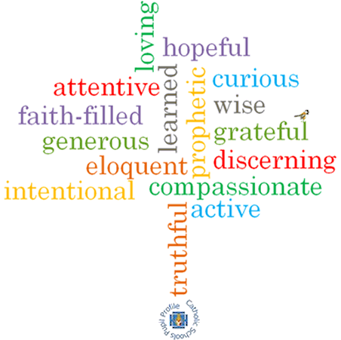

**Topic: Death & New Life**

**Strand: Lent/Easter**

**Phase: UKS2**

**Come and See Knowledge Organiser**

**What should I already know?**

Lent is a time of giving in preparation for the celebration of the sacrifice of Jesus.

**Big Questions**

Why does loss and death bring about change?

How do people cope with loss and death?

**Vocabulary I will need to use**

|  |  |
| --- | --- |
| Loss | The fact or process of losing something or someone. |
| Death | the action or fact of dying or being killed; the end of the life of a person or organism. |
| Change | Make or become different. |
| Growth | The process of increasing in size. |
| Ash Wednesday | The first day of Lent marked by services of penitence. |
| Lent | The period preceding Easter, which is devoted to fasting, abstinence, penitence and alms giving. |
| Holy Week | The week before Easter, beginning on Palm Sunday. |
| The Triduum | A period of 2 days observance – Maundy Thursday, Good Friday & Holy Saturday. |
| Easter Vigil | The ceremonies of Holy Saturday & the ost solemn memorial of the liturgical year. Consists of four parts; the service of light, Liturgy of the Word, Liturgy of Baptism and Liturgy of the Eucharist. |
| Resurrection | The rising of Christ from the dead. |

**What I will learn?**

**Make links** to show how feelings and beliefs about loss and death affect their behaviour and that of others.

**Compare** their own and other people’s ideas about questions concerning loss and death which are difficult to answer.

**Make links** between Scripture and belief in the Resurrection of Jesus.

Use a developing vocabularyto **give reasons** for religious actions and symbols connected with Lent, Holy Week and the Sacred Paschal Triduum.

**Give** **reasons** for certain actions by believers during Lent.

**Show how** their own and others’ decisions concerning the effects of death and loss are informed by beliefs and values.

**Describe and show understanding** of religious sources, beliefs, ideas, feelings and experiences connected with Lent, Good Friday of the Passion of the Lord; and The Easter Vigil in the Holy Night; making links between them.   
Use a variety of religious terms accuratelyto **show an understanding** of the different liturgies of Ash Wednesday, Lent, Good Friday of the Passion of the Lord; and The Easter Vigil in the Holy Night.

**Show understanding** of how religious belief in death and new life shapes life.

**Engage with and respond** to questions about death and new life in the light of religious teaching.

**Virtues**

**Scripture I will hear:**

John 6: 35, 37,51, 60,67-68

John 11: 1-43

John 12: 24-25

John 19: 16-21, 25-30, 38-42

John 20: 1-8