Vocabulary
Taxonomy | The part of science focused on classification.
Microorganism | An organism of microscopic size.
Myriapod | A group of arthropods with a body made up of numerous similar body segments e.g. millipede.
Arachnid | Arachnids are insects that have eight legs but don’t have an antennae.
Crustacean | A species becomes extinct when the last existing member of that species dies.
Car Linnaeus | Carl Linnaeus is famous for his work in taxonomy – the science of identifying, naming and classifying organisms.
Sticky knowledge
There are three types of micro-organism: viruses, fungi and bacteria.
Germs are disease-causing bacteria.
An arthropod is an invertebrate with a hard, external skeleton and jointed limbs.
Insects are a type of arthropod; their bodies consist of six legs, a head, a thorax and an abdomen; most insects also have a pair of antennae and a pair of wings.
An arachnid (e.g. spider) is a type of arthropod with eight legs and no antennae or wings.
A crustacean is a type of arthropod with two pairs of antennae (e.g. woodlouse).
A myriapod is an arthropod with a flat and long or cylindrical body and many legs (e.g. centipede).
The platypus was discovered in 1797 and scientists around the world attempted to classify this unusual animal. It seemed to have characteristics from several different types of animals.

Objectives
-describe how living things are classified into broad groups according to common observable characteristics and based on similarities and differences, including micro-organisms, plants and animals
-give reasons for classifying plants and animals based on specific characteristics.

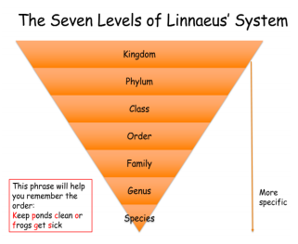
Microorganisms are very tiny living things. They are so small that they are not visible to the naked eye, so a microscope is needed to see them. All microorganisms share similarities and differences and can be classified using the Linnaean taxonomic system.

