Vocabulary
Refraction | Refractions is the bending of light as it passes from one medium to another.
Visible spectrum | The range of colours we can see with our eyes.
Concave | A lens that curves inwards and reflects light differently as a result.
Lens | A lens is a curved piece of glass or plastic designed to refract light in a specific way.
Retina | The retina is at the back of your eye and it has light-sensitive cells called rods and cones.
Iris | By opening and closing the pupil, the iris can control the amount of light that enters the eye.
Pupil | The dark circular opening in the centre of the iris of the eye, which varies in size to regulate the amount of light reaching the retina
Light and technology
Light also powers the technology around us: laser beams make CD and DVD players and printers possible, microscopes and telescopes use lenses to bend light (refraction), cameras record light as it reflects off objects and fibre-optic cables and lasers allow us to communicate at incredible speed.
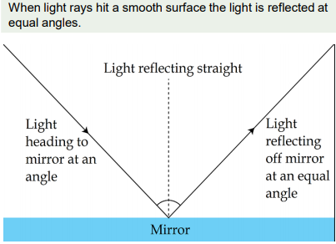
Objectives
-recognise that light appears to travel in straight lines
-use the idea that light travels in straight lines to explain that objects are seen because they give out or reflect light into the eye
-explain that we see things because light travels from light sources to our eyes or from light sources to objects and then to our eyes
-use the idea that light travels in straight lines to explain why shadows have the same shape as the objects that cast them

Sticky knowledge
Light travels in straight lines. When light hits an object, it is reflected (bounces off) and enters our eyes. This is how we see the object.
Light waves travel at a different speed when they go through other transparent materials, such as water or glass. This causes the rays of light to change direction and bend. This is known as refraction.
Light passes from one medium to another (e.g. from air to water), it changes direction; this is called refraction; this happens because light travels at different speeds in different mediums.
When light reflects off an object, the angle of incidence is equal to the angle of reflection.
White light comprises all the colours of light.
A periscope takes advantage of the predictable angles of incidence and reflection to allow an image to be shown to a viewer.
