Vocabulary
Gestation | Gestation, in mammals, is the time between conception and birth.
Reproduction | The way plants and animals make new plants and animals. A new offspring is produced from their parents.
Childhood | The age span ranging from birth to adolescence.
Adolescence | The time when a child develops into an adult.
Life span | The length of time something lives for.
Embryo | A newly fertilised egg in the womb.
Foetus | An unborn baby that has developed from an embryo.
Average gestation period of mammals
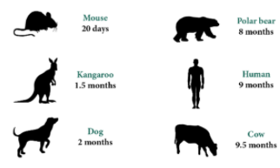
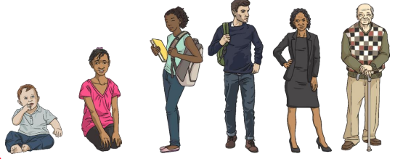

Can you write the different stages of developmental under each picture?
Objectives
-describe the changes as humans develop to old age
Sticky knowledge
Humans go through stages of development. They begin as fertilised eggs and then develop into embryos before developing into babies.
Once they are born, these newborn babies become infants (roughly 2 months to 2 years) then into young children (roughly 2-12 years old).
The years between 6 and 14 -middle childhood and early adolescence - are a time of important developmental advances that establish children's sense of identity.
As adults develop into old age (roughly 55+ years old) they experience changes in their body which require them to move more carefully and rest more frequently
When some animals are born, they can already swim or walk. Some are able to find their own food. Some of these animals become adults in a few weeks and are then able to reproduce and have offspring of their own.

