Vocabulary
Air resistance | A type of friction between air and another material. For example, when an aeroplane flies through the air.
Water resistance | Friction between water particles and n object moving through water. For example, if you go swimming, there is friction between your skin and the water particles.
Levers | A tool used to lift or pry things open.
Pulleys | A simple machine that makes lifting something easier. A pulley has wheel or set of wheels with grooves that a rope or chain can be pulled over.
Gears | A part of a machine that causes another part to move because of teeth which connect the two moving parts.
Springs | A spiral of wire which returns to its original shape after it is pressed or pulled.
Transference | The action of transferring something or the process of being transferred.
Objectives
-explain that unsupported objects fall towards the Earth because of the force of gravity acting between the Earth and the falling object
-identify the effects of air resistance, water resistance and friction that act between moving surfaces
-recognise that some mechanisms, including levers, pulleys and gears, allow a smaller force to have a greater effect
Galileo conducted a famous experiment in which he dropped two objects from the Leaning tower of Pisa in 1589. He wanted to prove that the pull of gravity on an object is the same, regardless of their different weights.

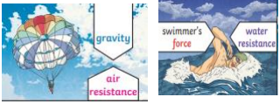
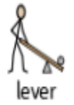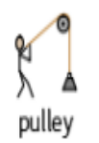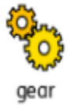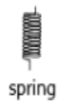
Sticky knowledge
A force is measured in a unit called Newtons, named after a British scientist called Sir Isaac Newton who discovered lots about gravity and how planets move.
Gravity is a force that acts between all objects in the universe, but it acts much more strongly between objects that have more mass and that are close together.
Air resistance is the force on an object moving through air, such as a plane moving through the sky. Air resistance affects how fast or slowly objects move through the air.
Water resistance is the force on objects floating on or moving in water.
Gears, levers and pulleys are simple machines used to allow a smaller force to have a greater effect.
A parachute’s shape increases the air resistance that a falling object experiences, giving it a much lower terminal velocity.
A falling object will accelerate until its air resistance matches the gravitational force pulling it down.

