Vocabulary
Vibrating | Sound is caused by the vibration of a medium (usually air) and it travels in waves.
Pitch | How high or low a sound is.
Volume | The loudness of a sound.
Amplitude | The size of a vibration. A larger amplitude = a louder sound.
Sound wave | Vibrations travelling from a sound source.
Soundproof | To prevent sound from passing.
Auditory | Auditory is close in meaning to acoustic, but auditory usually refers to hearing rather than sound.
Frequency | Frequency is measured as the number of wave cycles that occur in one second.
Insulation | Protecting something by surrounding it with material that reduces or prevents the transmission of sound.
Sticky knowledge
Sound comes from vibrations. These vibrations create sound waves which move through mediums, such as air, before reaching our ears.
Longitudinal sound waves are detected in the ear by humans and the brain interprets this as the sounds we hear.
Sound travels at different speeds through different objects.
Pitch is how high or low a sound is and this is determined by how many vibrations per second are being made by the vibrating object.
The number of vibrations per second is called frequency.
Volume is how loud or quiet a sound is and it is determined by the amount of energy in the wave.
The volume of a sound is quieter if the listener is further away from the object.

Objectives
-identify how sounds are made, associating some of them with something vibrating
-recognise that vibrations from sounds travel through a medium to the ear
-find patterns between the pitch of a sound and features of the object that produced it
-find patterns between the volume of a sound and the strength of the vibrations that produced it
-recognise that sounds get fainter as the distance from the sound source increases
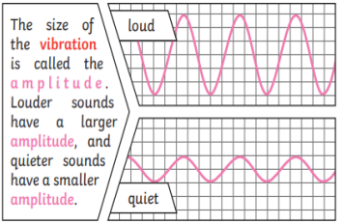
Is the speed of sound faster or slower than light? Can you think of an example to prove your answer?

