A Guide for Uploading Work

- The children can upload work via the Seesaw website (https://app.seesaw.me/) or through the ‘Seesaw Class’ app. See the Parent & Children Guide to Seesaw on our website for more information on accessing the site.
- To respond to an activity, children should click on the green + sign.
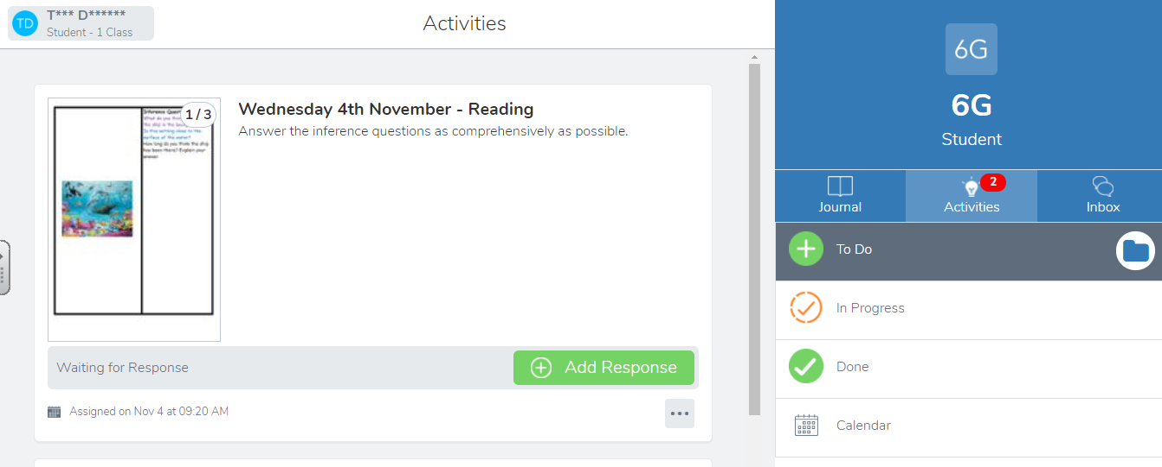

You will then be taken to a page similar to this where you can click on the camera icon. You can then choose to upload a photo or video directly. Or you can choose to upload a file.

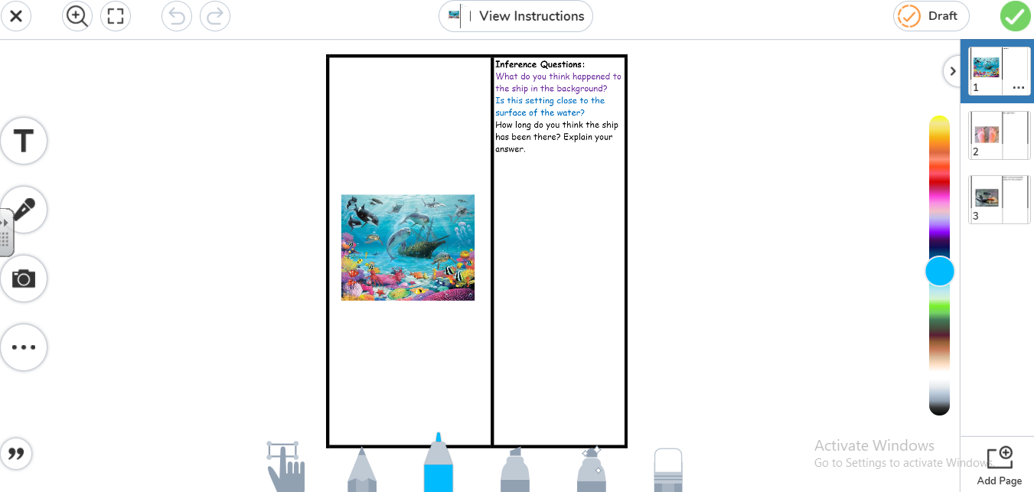
Once you have uploaded your work, click on the green tick in the top right hand corner.

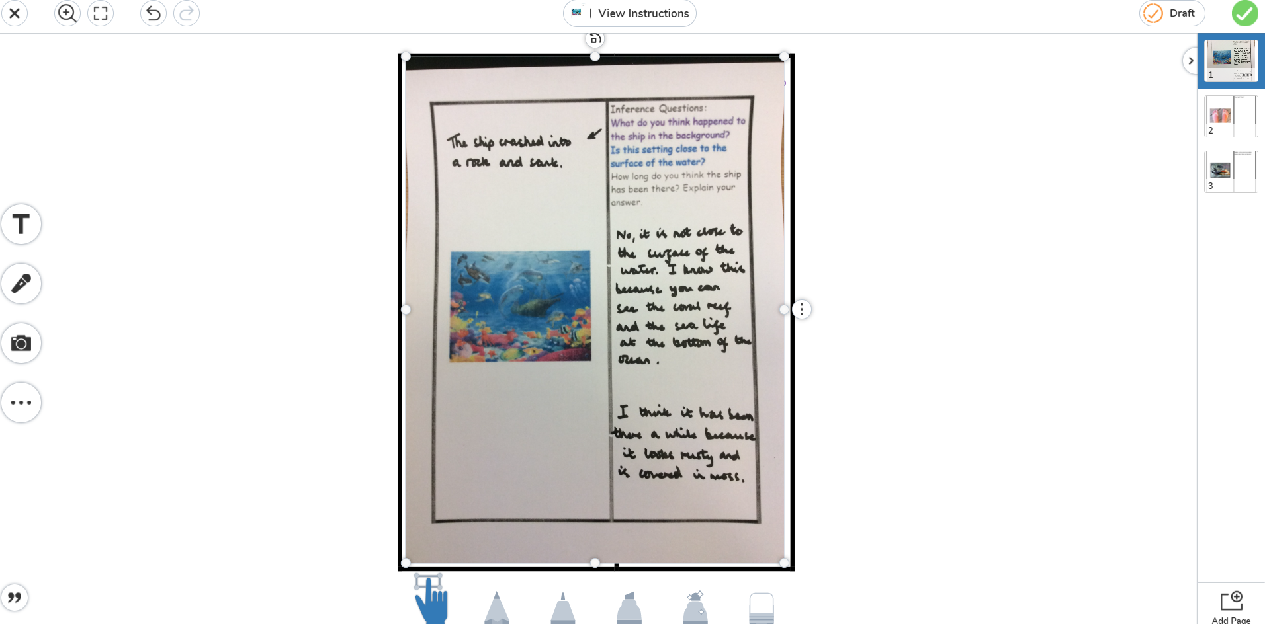

Your work should now be uploaded and will await teacher approval.

