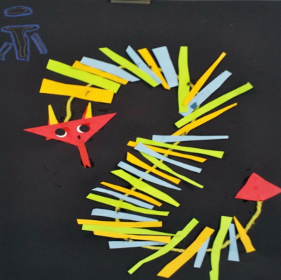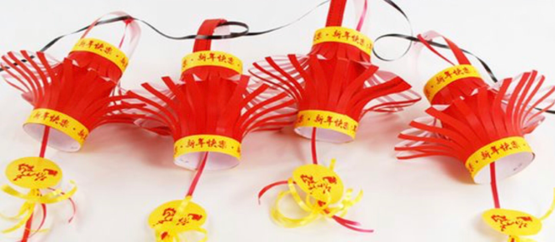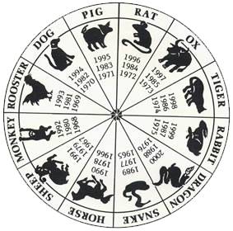

**The Great Race:**

Legend has it that we celebrate Chinese New Year as a result of the Jade Emperor’s desire to name the years and measure time. He arranged a race which was won by the rat and all the other animals followed as depicted on this wheel, this is the Year of the rooster.

**Welcome to St. Margaret Mary’s Chinese New Year Exhibition.**

Each class has developed their skills to produce work and artefacts in celebration of Chinese New Year.

We hope that you enjoy our work!

**Kung Hey Fat Choy!-Happy New Year!**

**About Chinese New Year:**

Chinese New Year is the Chinese festival marking the start of the new year, beginning on the second new moon after the winter solstice and ending on the full moon fifteen days later. It is marked by visits to family and friends, special meals, fireworks, and gift giving.

