**Being British- An Exhibition**

**The children of St. Margaret Mary’s have explored the fundamental British values that we share:**

* Democracy.
* The rule of law.
* Individual liberty.
* Mutual respect for and tolerance of those with different faiths and beliefs and for those without faith.

They have done this through an exploration of art, literature, poetry, myth and legend.

* They have also explored Britishness, famous Britons, Democracy, sport and customs.
* We also dressed in red, white and blue or famous Britons and celebrated St. George’s day and the Queen’s birthday.
* We hope that you enjoy our exhibition!

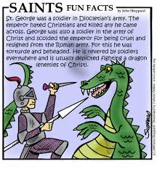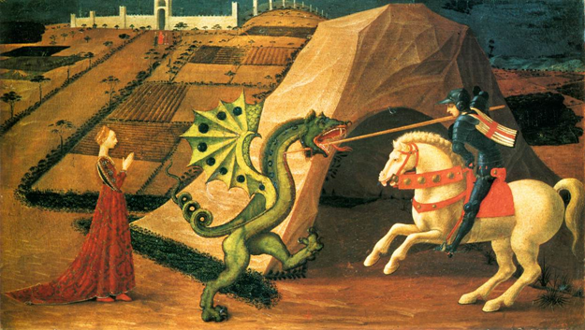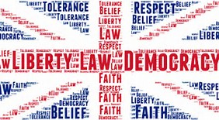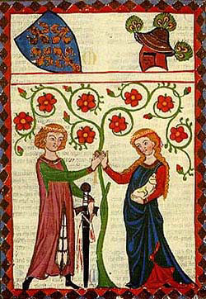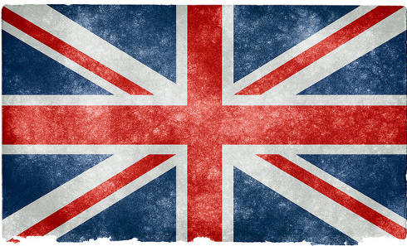

The Union Jack has the St. George cross of England in the middle.

**Art Club – Y1/Y2**

Children who attended Art Club made St George and the Dragon collages and a large model of St. George.

**The Y1/Y2 children**

The children designed shields and created symbols for them.

They also produced writing on the British theme.

The **EYFS** children explored the legend of St. George and the Dragon, and found out how the dragon was slain, and how the red rose then blossomed.

The Nursery children made celery rose prints and worked as a team to make Union Jack flags.

The Reception children made pictures of St. George in his armour, flags and dragons.

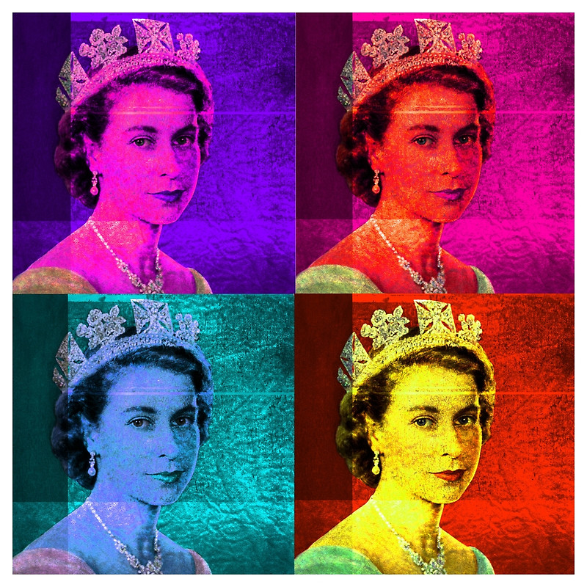

“Happy Birthday Your Majesty!”

We celebrated the Queen’s birthday she is 91 this year.

Year 6 children created silhouettes of famous British landmarks.

They also explored Democracy.

Year 5 children explored the work of Street Artist, Banksy and created their own Wall Art.

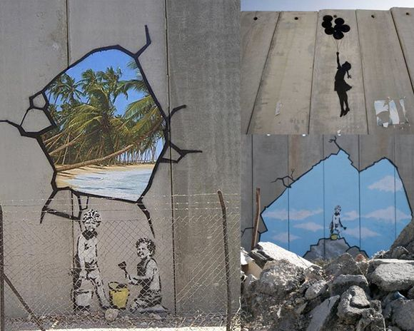

Year 3 and 4 children created Pop Art.