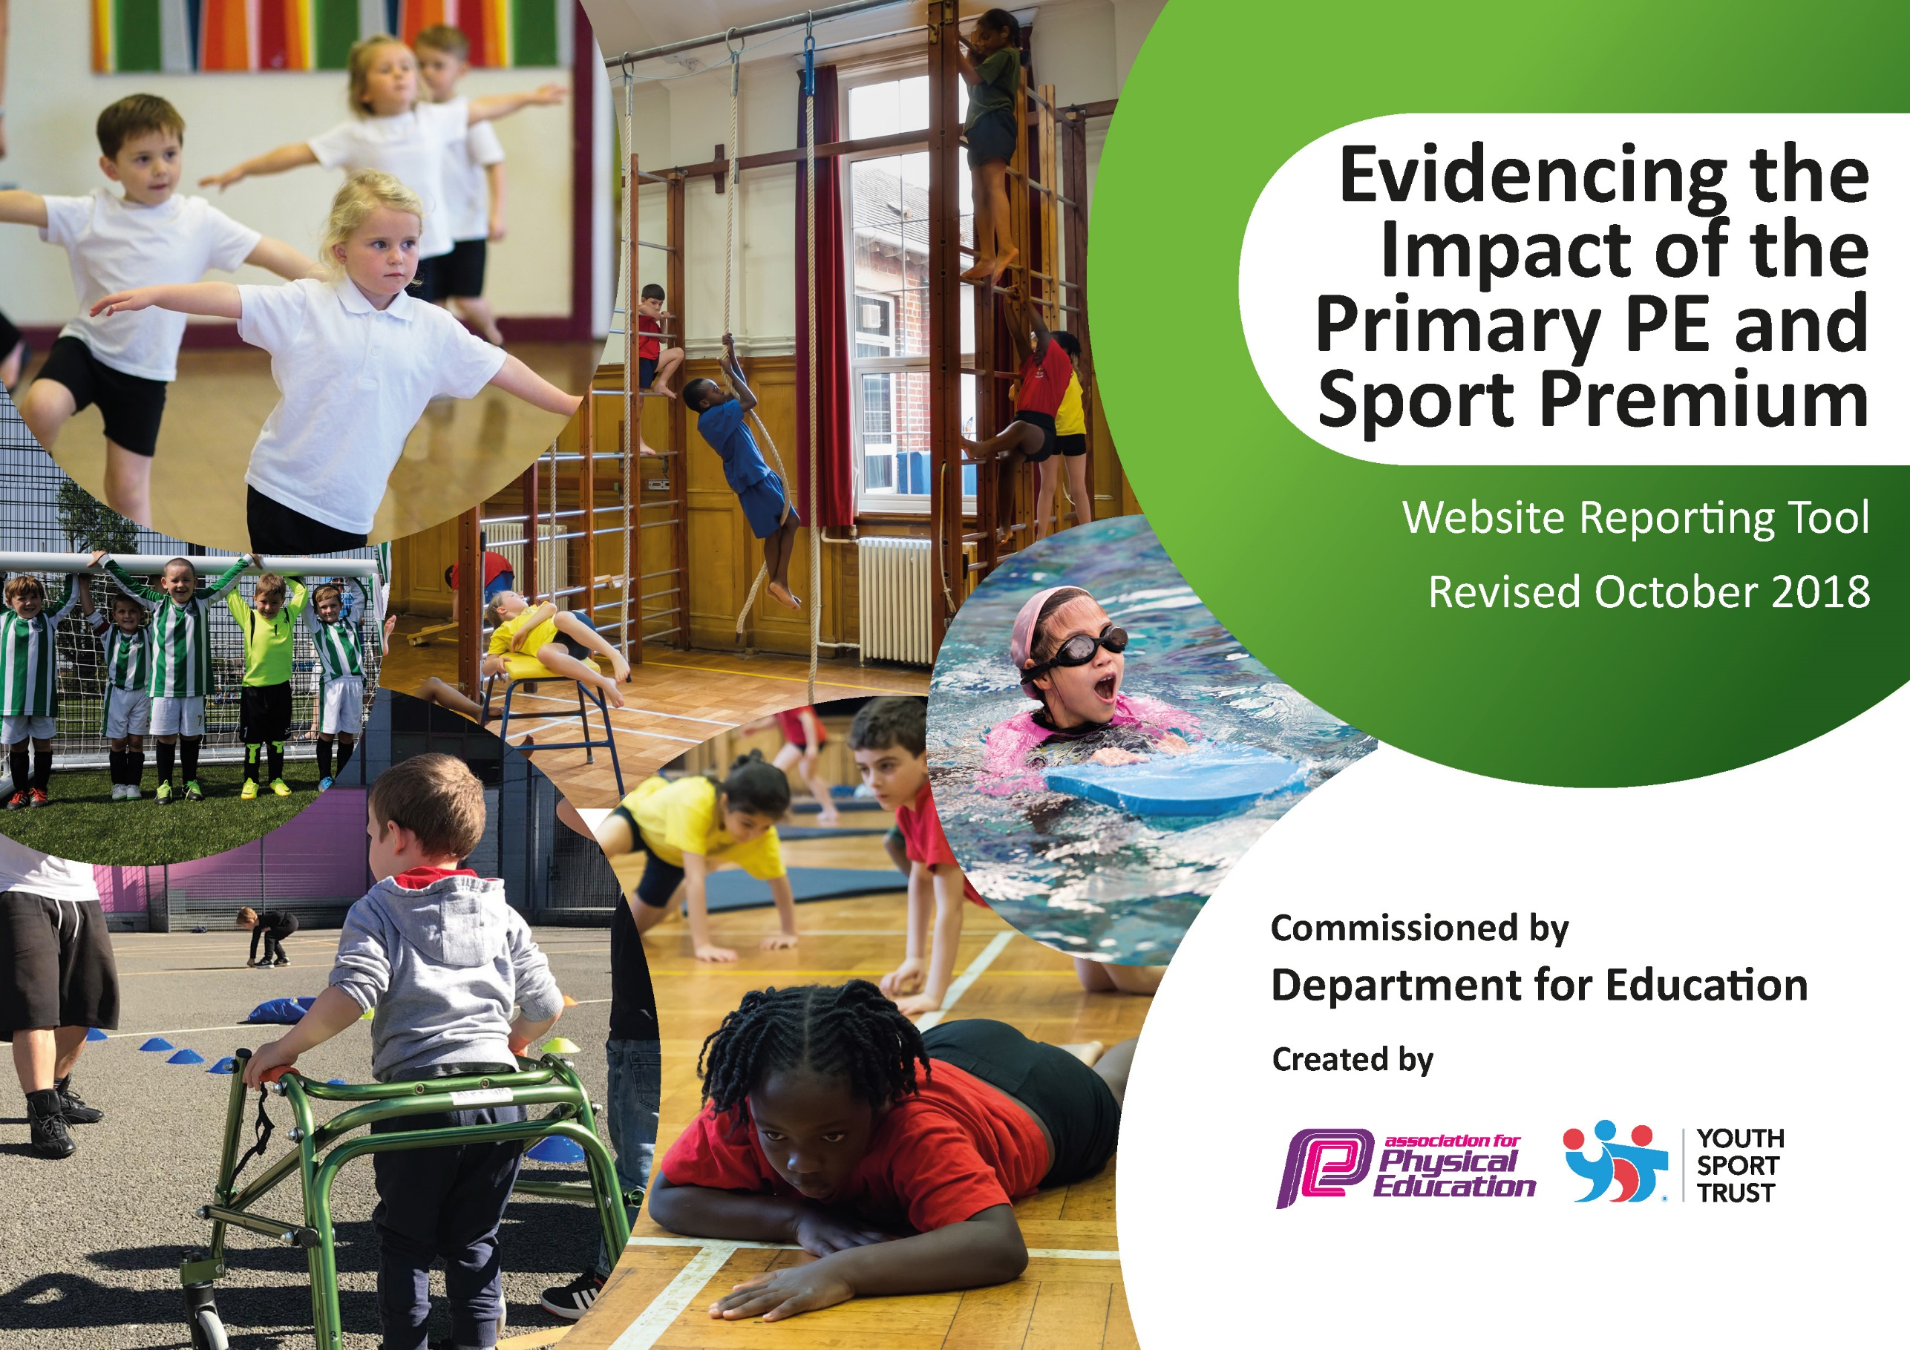
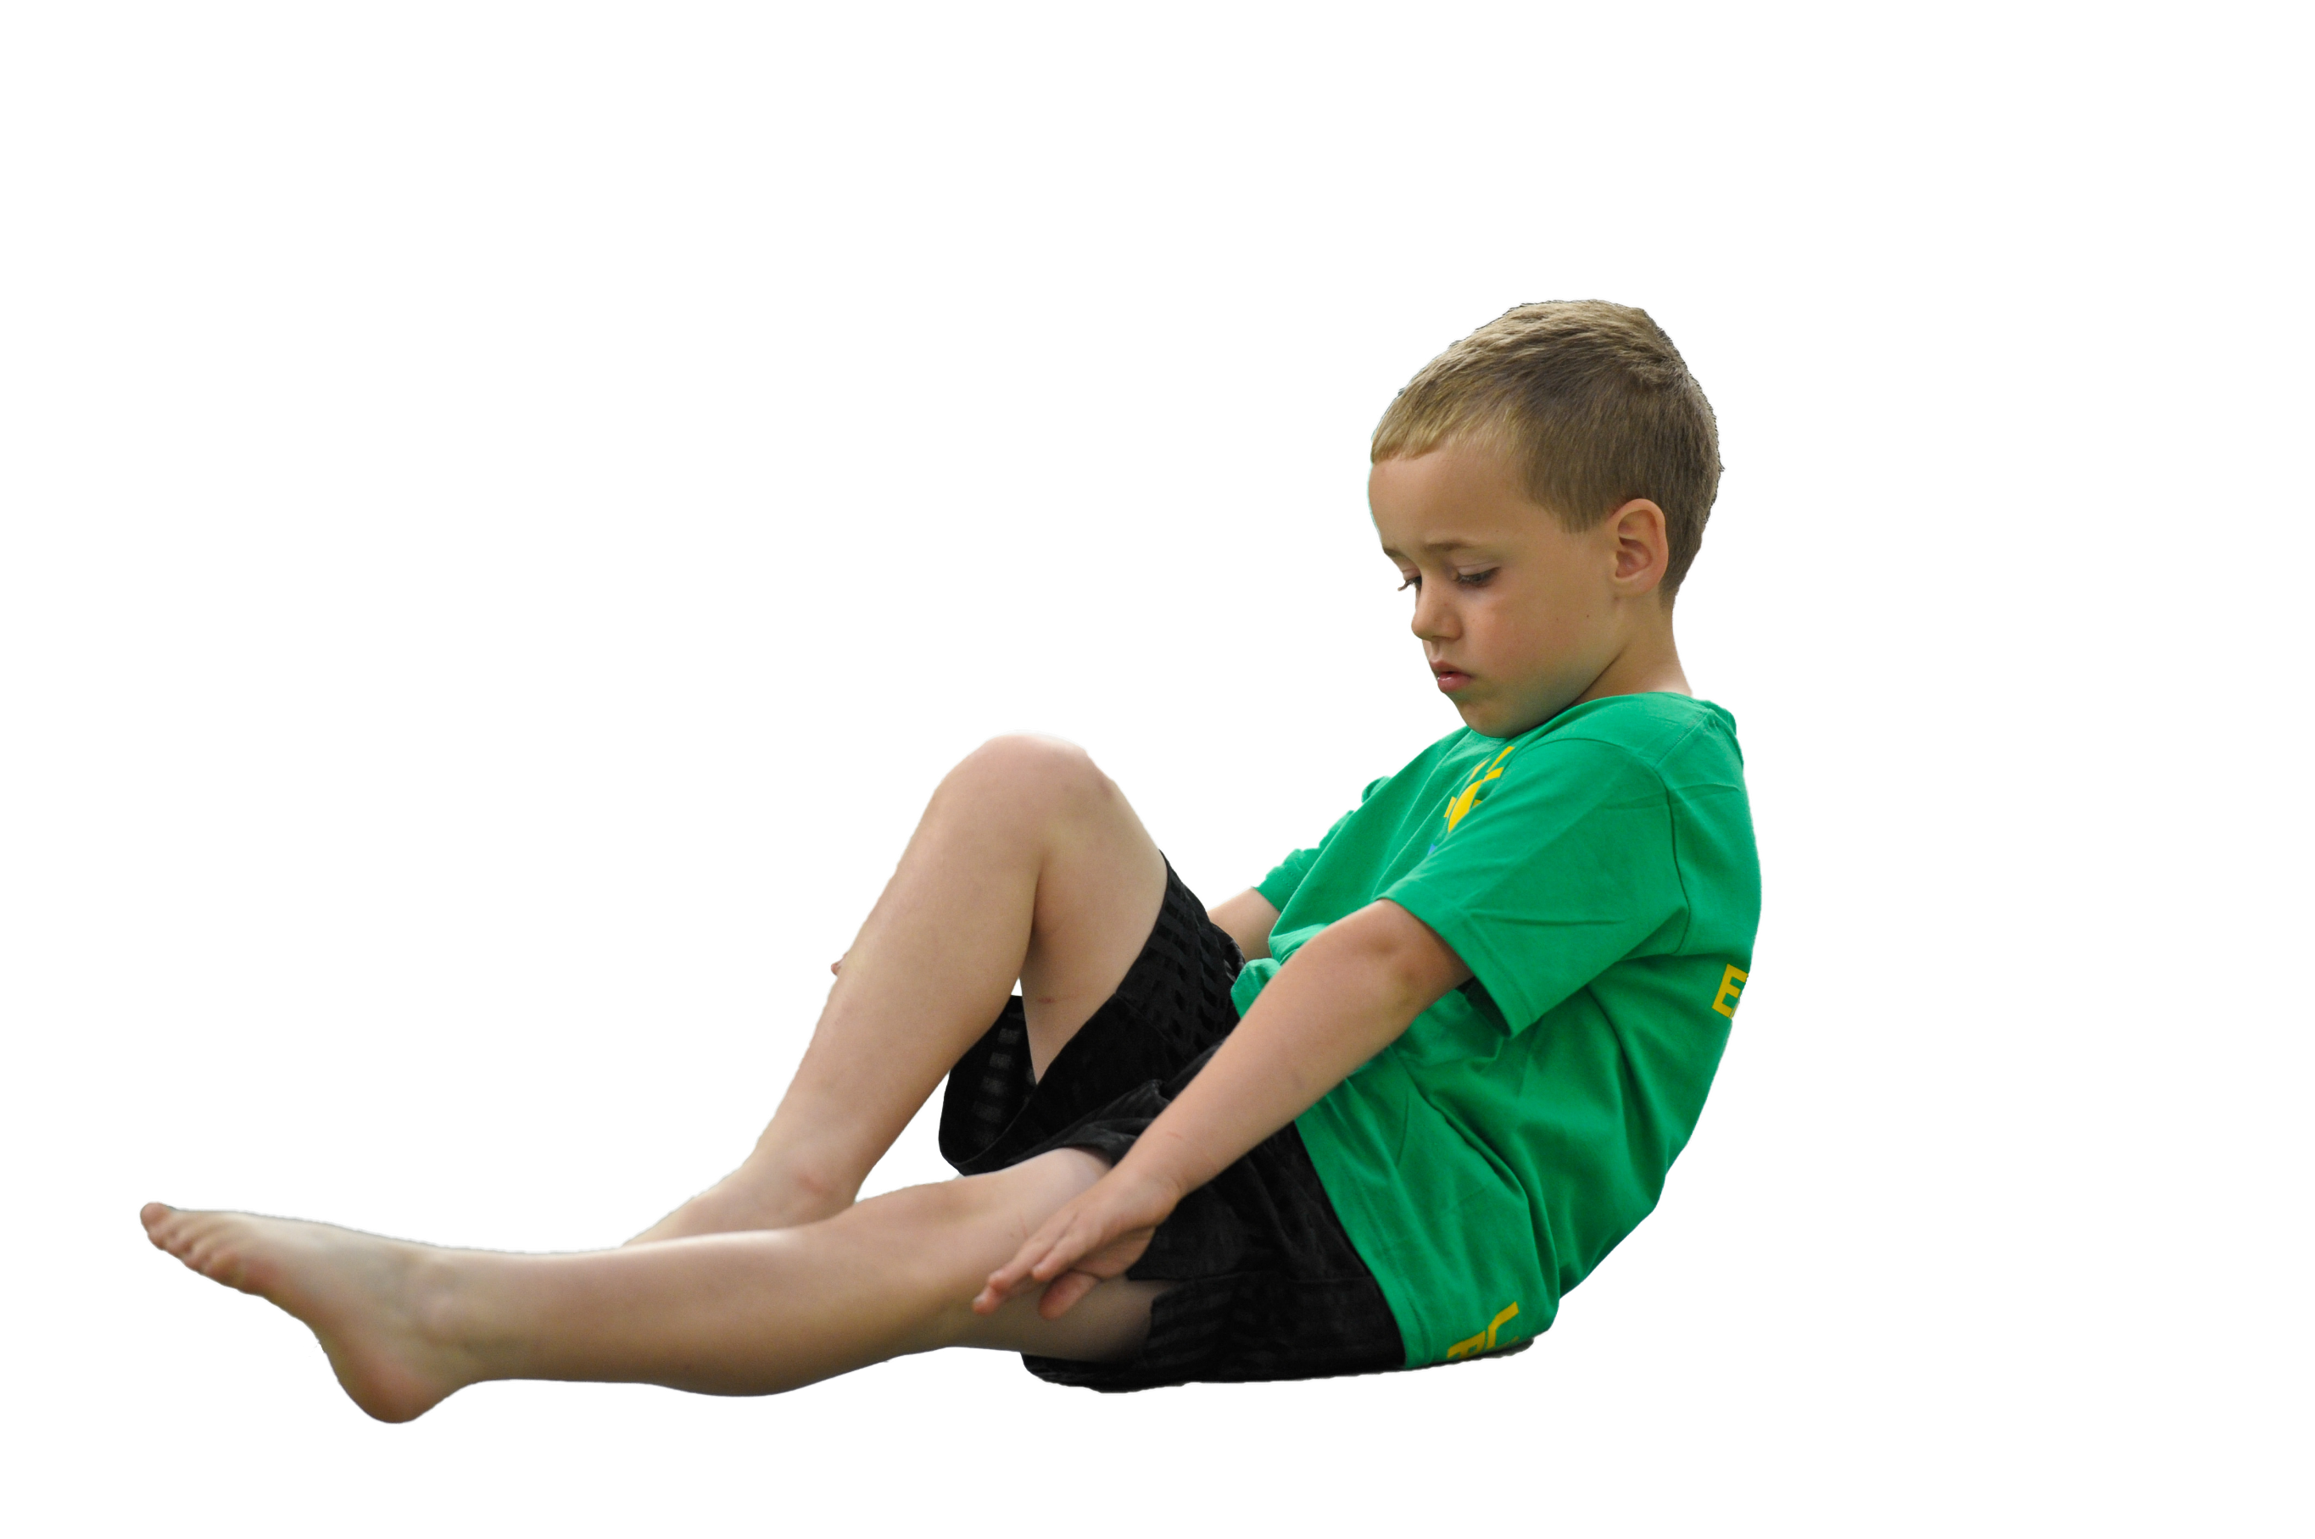
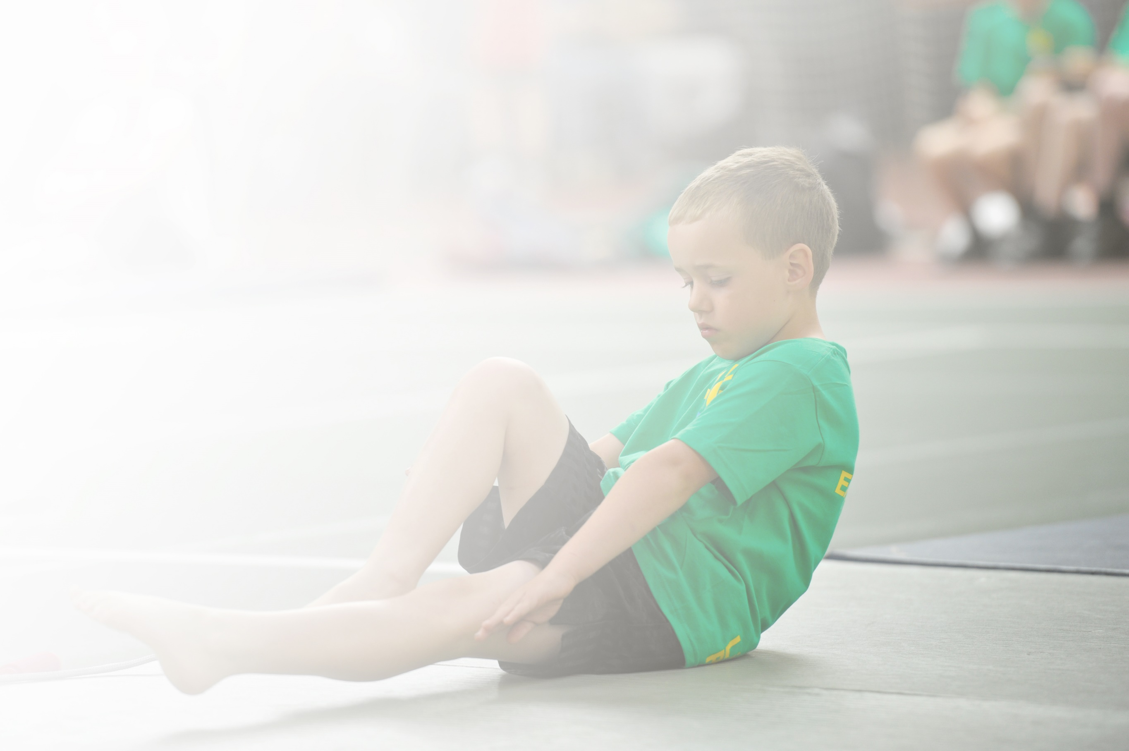
Schools must use the funding to make additional and sustainable improvements to the quality of Physical Education, Sport and Physical Activity (PESPA) they offer. This means that you should use the Primary PE and Sport Premium to:

- Develop or add to the PESPA activities that your school already offer
- Build capacity and capability within the school to ensure that improvements made now will benefit pupils joining the school in future years

Please visit gov.uk for the revised DfE guidance including the 5 key indicators across which schools should demonstrate an improvement. This document will help you to review your provision and to report
your spend. DfE encourages schools to use this template as an effective way of meeting the reporting requirements of the Primary PE and Sport Premium.

We recommend you start by reflecting on the impact of current provision and reviewing the previous
spend. Under the Ofsted Schools Inspection Framework, inspectors will assess how effectively leaders use the Primary PE and Sport Premium and measure its impact on outcomes for pupils, and how effectively governors hold them to account for this.

Schools are required to publish details of how they spend this funding as well as on the impact it has on pupils’ PE and sport participation and attainment by the end of the summer term or by 31 July 2019 at the
latest.
We recommend regularly updating the table and publishing it
on your website throughout the year, as evidence of your
ongoing review into how you are using the money to
secure maximum, sustainable impact. To see an
example of how to complete the table please
click HERE.

St Margaret Mary’s RC Primary School PE Premium Evaluation & Impact 2018-2019

Key achievements to date: | Areas for further improvement and baseline evidence of need:
Improved staff expertise and confidence leading to the quality delivery of P.E. lessons  Pupils provided with broader experiences in P.E./sport and joining out of school sports clubs.  Provided a diverse and wide range of extra-curricular clubs and activities.  Healthy competitive attitudes and increased participation in competitions.  All pupils engaged in regular physical activity – leading to long term positive healthy lifestyle choices. | Continue to increase staff expertise and confidence leading to the improved quality delivery of P.E. lessons  Continue to provide children with broader experiences in P.E./sport  Continue to increase children’s activity levels within school

Meeting national curriculum requirements for swimming and water safety 2018-2019 | Please complete all of the below:
What percentage of your current Year 6 cohort swim competently, confidently and proficiently over a distance of at least 25 metres?  N.B. Even though your children may swim in another year please report on their attainment on leaving  Primary school. | 88.04%
What percentage of your current Year 6 cohort use a range of strokes effectively [for example, front crawl, backstroke and breaststroke]? | 63.04%
What percentage of your current Year 6 cohort perform safe self-rescue in different water-based situations? | N/A
Schools can choose to use the Primary PE and Sport Premium to provide additional provision for swimming but this must be for activity over and above the national curriculum requirements. Have you used it in this way? | No

St Margaret Mary’s RC Primary School PE Premium Evaluation & Impact 2018-2019

Academic Year: 2018/19 | Total fund allocated: £17,900 | Date Updated: July 2019
Key indicator 1: The engagement of all pupils in regular physical activity – Chief Medical Officer guidelines recommend that primary school children undertake at least 30 minutes of physical activity a day in school
School focus with clarity on intended impact on pupils: | Actions to achieve: | Funding allocated: | Evidence and impact: | Sustainability and suggested next steps:
Signing-Up to Daily Mile Initiative & creating playground markings  Purchase of resources and equipment to support playground activities and competition  Purchase of Maths of the Day programme to increase children’s activity levels | School to sign up to Daily Mile scheme to encourage all children & staff to run 1 mile every-day.  Resources to be purchased with, the playground being marked out with a route to support this.  Information provided to parents explaining the reasoning & intended impact & benefits of the Daily Mile.  Identify resources needed to increase the range of sports provided at lunchtimes and for intra school competitions.  Sign up to Maths of the Day programme  Provide staff, parents and children with the necessary information explaining the many benefits of being active in maths lessons. | £2,250  £1,250  £1,650 | Evidence:  Invoice/Daily Mile Scheme/Letter to Parents/Daily Mile trackers and timetable/Daily Mile Rewards  Impact:  School grounds marked with the Daily Mile track and year groups are using the Daily Mile regularly to increase their activity levels. This has increased children’s engagement with physical activity and developed their knowledge and understanding of a healthy and active lifestyle.  All children, in all year-groups completing the Daily Mile.  Regular participation resulting in increased fitness, stamina & enjoyment for all.  Pupil Questionnaires highlighted all pupils enjoyed the DM  Evidence:  Invoices, PE equipment audit  Impact:  The new resources have encouraged children to participate in sporting activities during their lunchtimes, which has increased their opportunities for physical activity during the school day.  Children have a range of intra-school sporting competitions that they compete in weekly, as well as a personal challenge activity every Friday.  Quality of activities benefitting pupil well-being & enjoyment  Evidence:  Invoices  Impact:  The programme will be purchased at the end of the Summer term, so the impact will be available at a future date. The programme will provide children extra opportunities to be active in school, which will provide them with a healthier and more active lifestyle. | Continue to monitor the impact of the Daily Mile.  Encourage year groups to increase their participation in the Daily Mile.  Try to incorporate physical activity into more lessons. Eg. Active Maths, Active English etc.  Continue to monitor resources needed and to provide intra-school sporting competitions and personal challenge days using the sporting equipment and resources.  Purchase Maths of the Day programme and implement it across the school.
Key indicator 2: The profile of PESSPA being raised across the school as a tool for whole school improvement
School focus with clarity on intended impact on pupils: | Actions to achieve: | Funding allocated: | Evidence and impact: | Sustainability and suggested next steps:
Purchase of additional resources & equipment to support PE Provision & Wider Sports Clubs | Identify resources and equipment needed to support learning & the teaching of P.E. across key stages.  Identify resources needed to increase the range of sports clubs provided | £1,275 | Evidence:  Invoices and PE equipment audit  Impact:  The purchase of the equipment has increased the range of sports, provided for the children, by after school clubs such as boxing activities, multi-sports, rugby, football and netball.  Pupil questionnaires highlighted increased participation & enjoyment  The equipment has enabled the children to have a more enriched P.E. provision throughout the school day & all-year round.  Sports Day, as there were more activities available. Eg, Basketball nets for practising shooting skills.  Supported the teaching of PE across the key stages, with more resources being available for improved quality of lessons. | Continue to monitor the impact of the purchased resources and staff to ensure that they are providing a range of sporting experiences for the children, using the resources.

Key indicator 3: Increased confidence, knowledge and skills of all staff in teaching PE and sport
School focus with clarity on intended  impact on pupils: | Actions to achieve: | Funding  allocated: | Evidence and impact: | Sustainability and suggested  next steps:
Confident delivery of high quality P.E. lessons ensuring pupils develop their skills in a range of sporting activities.  Increased physical activity and parental engagement. Families making healthier lifestyle choices for their children. | Contract with accredited external sports provider –  City In The Community [MCFC]. Provides sports coach to support staff CPD and provide break time and after school activities. Also providing enrichment activities such as football for EYFS, sports disability awareness and healthy cooking sessions for pupils and parents.  Contract with accredited external sports provider – Beth Tweddle Gymnastics  Provides sports coach to support staff CPD  PE Coordinator to attend subject leadership meetings to develop confidence in leading PE in the school | £9,300  £3,200  £250 | Impact:  Teachers’ ability and confidence in the delivery of PE has improved due to their improved subject knowledge. This has improved the quality of the PE lessons for children across the school. See lesson observations & evaluations.  Targeted support provided for NQTs/RQTs.  High Quality CPD provided for staff to support quality teaching. Impact evident in lessons & skill acquisition by children.  Improved outcomes for pupils evidenced through end of topic assessments for all age-groups.  More confident assessments  Pupils and parents are making healthier lifestyle choices with the food choices they are giving their children for lunches/snacks. This is leading to children living a healthier lifestyle.  Use of City Cooks Programme to support this.  Teachers’ ability and confidence in the delivery of gymnastics has improved due to their improved subject knowledge. This has improved the quality of the gymnastics lessons for children across the school.  Children receiving better quality gymnastics teaching across all year groups. Resulting in improved technique & skill acquisition from review of tasks assessments & lesson observations. See end of topic assessments.  Evidence:  Subject leadership meeting invoices and CPD invoices  PE coordinator’s confidence in leading PE significantly developed throughout the year, resulting in the standard of PE and School Sport increasing throughout the school, and improving the children’s sporting experiences. | Continue to develop teacher confidence in different aspects of PE.  Continue to increase engagement among pupils and parents in the next year.  Teachers to build on their gymnastics confidence in the coming year.
Key indicator 4: Broader experience of a range of sports and activities offered to all pupils
School focus with clarity on intended  impact on pupils: | Actions to achieve: | Funding  allocated: | Evidence and impact: | Sustainability and suggested  next steps:
Introduce children to broader experiences in sport and encourage commitment and longevity in healthy lifestyle choices. | Specialist coaches employed to deliver sessions each week before or after school. | £3300 | Evidence:  Requisition/Invoice + register. Certification. School Competition Entries.  Children are making healthier lifestyle choices. Children have increased self-discipline and commitment. Children have had increased opportunities for competition through their broader experiences.  This has resulted in the school receiving the Silver Games Award in 2019. | To continue the delivery of high standard broader experience sessions.  Develop more external links to encourage children’s engagement beyond primary school.
Key indicator 5: Increased participation in competitive sport
School focus with clarity on intended  impact on pupils: | Actions to achieve: | Funding  allocated: | Evidence and impact: | Sustainability and suggested  next steps:
Children to participate in regular competitions across Manchester & with local schools (at least a team competing fortnightly.  Minibus & transportation needed to venues | P.E. Team have booked the school into competitions matching after-school clubs & training sessions to prepare the children (rolling programme).  Hiring minibus and transportation to sporting events. Rolling Programme of transportation booked in for key events & sporting enrichment to allow children to access events around the city.  Coordinated by P.E. Lead & Administrative Assistant | £1500  £650 | Evidence:  Participation in events, registers for competitions, hire of minibuses etc…  Impact:  Children have received a number of opportunities to compete in their desired sporting activity. This has allowed them to develop their sporting skills & take part in more events & competitions.  This has resulted in the Silver Games Award 2019  Evidence:  Minibus requisitions & invoices  Children have participated in a range of sporting activities during & outside of school time through the Manchester P.E. & School Sports Group, from;  Football, Hockey, Kwik-Cricket, Multi-Sports, Swimming-Galas, Athletics, Gymnastics Cross-Country, Basketball and Gaelic Football.  Across all age-ranges, participation in City-Wide & Inter-School Sports Competitions increased.  Children gained further experience of inter-school competition & the school has received the School Games Silver Award (improving on the Bronze award last year). | To continue regularly entering the school into competitions across Manchester & with local schools.  Look to increase the number of sporting competitions entered.  To continue the rolling programme of transportation booked in for key events & sporting enrichment.

