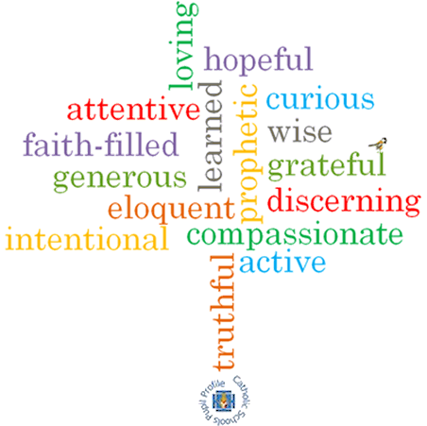

**Strand: Lent/Easter**

**Phase: EYFS**

**Topic: Growing**

**Come and See Knowledge Organiser**

**Virtues**

**What I will learn**

I will learn to **talk about** my experience of growing and how I feel about it.

I will begin to say what I **wonder** about.

I will **recognise** the stories of Good Friday & Easter Sunday.

I will begin to **recognise** the cross, the words of the Sign of the Cross & the Easter garden.

I will begin to **recognise** that Christians try to ‘grow more like Jesus’ particularly during Lent.

**Scripture I will hear:**

John 13: 34-35

John 19: 25-27

Acts 2: 23-24

Luke 2: 51-52

**Big Questions**

How and why do things grow?  
How do things grow?

What do things need to grow?

How do I grow ‘Inside’?

**Vocabulary I will need to use**

Looking forward to Easter

|  |  |
| --- | --- |
| grow | Something gets older. |
| spring | A season when things begin to grow. |
| different | Not the same. |
| Lent | A season of reflection and preparation. Last for 40 days and 40 nights beginning on Ash Wednesday. |
| Good Friday | The day Jesus was crucified and died. |
| Cross | A wooden shape that Jesus died upon. |
| Easter Sunday | The day Jesus rose from the dead. |

**What should I already know?**

Knowledge and experience of activities that are good to do together.