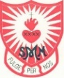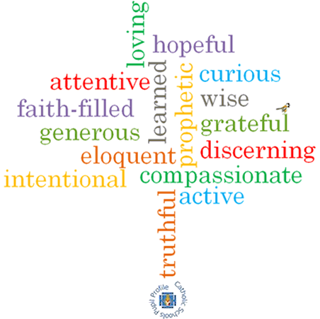

**Strand: Local Church**

**Topic: Celebrating**

**Come and See Knowledge Organiser**

**Phase: EYFS**

**Vocabulary I will need to use**

People celebrate with the parish family

|  |  |
| --- | --- |
| Church | a group of people called together to worship Jesus and God. This can be done in a building known as a Church. |
| Priest | A man whose job it is to tell and teach people about God and Jesus Christ his son. |
| Celebrate | Mark a special event with a gathering or special activity. |
| Celebrating | The action of marking a special event or occasion. |
| Parish family | A group of people belonging to a Church in a local area. |
| Family | People who are related to each other. |
| Community | People who live or work in an area together. |
| Celebration | The event that is used to mark a special occasion. |
| Party | A celebration of an event. |
| Memory | Something remembered that has already happened. |
| Father | A man who has a child, for example God is Jesus’ Father. |
| Altar | A special table in a Church. |
| Temple | A place where Jewish people go to pray and worship God. |
| parish | A local area of a Church community. |

**What I will learn**

I will begin to **talk** about my own experiences and feelings about celebrations I have been part of and how the celebration was shared.

I will begin to **wonder** about why people celebrate.

I will begin to **wonder** about how I feel when I celebrate.

I will begin to **recognise** the story of Mary and Joseph taking Jesus to the Temple.

I will begin to **recognise** some of the elements and words used in Church celebrations.

I will begin to **recognise** that the church/parish family celebrate in particular ways.

**What should I already know?**

Children will have experienced celebrations at home.

**Virtues**

**Scripture I will hear:**

Luke 2: 22

**Big Question**

What and why do people celebrate?

Can you celebrate on your own?