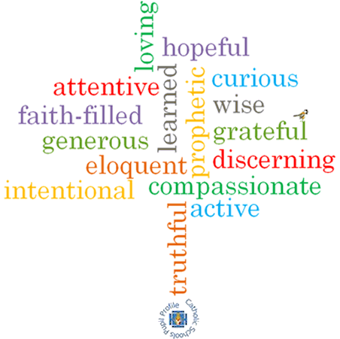

**Strand: Baptism/Confirmation**

**Topic: Welcome**

**Come and See Knowledge Organiser**

**Phase: EYFS**

**Virtues**

**What I will learn**

I will begin to **talk about** my own experiences and feelings of being welcomed.

I will begin to say what I **wonder about** how they can make others feel welcome.

I will begin to **recognise** some religious signs and symbols used in baptism.

I will begin to **use** some religious words and phrases from the Rite of Baptism.

**Vocabulary I will need to use**

a welcome for a new baby

|  |  |
| --- | --- |
| Welcome | Greeting someone in a polite or friendly way |
| Welcomed | How we make people feel when we welcome them |
| Belong | To be part of or a member of a group. |
| School | A building where we come together to learn. |
| Class | A group of children with teachers. |
| Baptism | A time where we are welcomed into God’s family and given a special name. |
| baptise | When a baptism takes place and water is poured onto the head of the person being welcomed into God’s family. |
| Water | A liquid that can be blessed to make it Holy. |
| Candle | A solid object made of wax which can be lit. The flame can represent Jesus being the light of the world. |
| In the name of… | Words we say at the start of a prayer. |
| family | People who we are related to. |
| priest | A man whose job it is to tell people about God and Jesus. |
| White garment | White clothes we wear when we are baptised. |
| Godparents | Adults that parents ask to do a special job to help raise a baby following God’s teachings. |
| font | A special container or bowl of Holy Water that is used when a person is baptised. |

**Scripture I will hear:**

Colossians 3:12

**What should I already know?**

Children will have experience of belonging to a family and to a class group in school.

**Big Questions**

Why is welcome important?

How do we show people that they are welcomed?

How is a baby welcomed into a family?

How are we welcomed into God’s family?