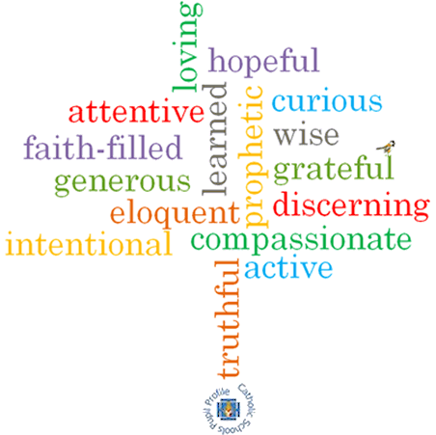v

**Strand: Advent/Christmas**

**Topic: Birthdays**

**Come and See Knowledge Organiser**

**Phase: EYFS**

**What I will learn**

I will **begin to talk about** my own feelings as they wait for a birthday.

I will **begin to talk about** my own experience of celebrating a birthday.

I will **begin to wonder** at the joy of birthdays.

I will **begin to recognise** the Nativity story.

I will **begin to recognise** that the Advent Wreath, the crib and other signs indicate the approach of Christmas.

I will **begin to use** and develop a vocabulary of religious words and phrases.

**Vocabulary I will need to use**

Looking forward to Jesus’ birthday

|  |  |
| --- | --- |
| Birthday | A celebration to remember the day a person was born. |
| Waiting | An action of staying where you are or delaying an action until something happens. |
| Wreath | A circle of green leaves. |
| Celebrate | A gathering or activity to mark a special event. |
| Christmas | The celebration of when Jesus was born. |
| Advent | A season in the Church’s year where we are waiting the arrival of Jesus. |
| Jesus | God’s son. |
| Mary | Jesus’ Mummy, chosen by God. |
| Joseph | Mary’s husband |
| Swaddling clothes | A type of blanket or clothing that would be wrapped around a baby. |
| Manger | A long container, usually made of wood where horses of cattle (cows) would feed. Jesus was laid in a manger when he was born in a stable. |
| Crib | A traditional bed for a baby. |
| Shepherds | People whose job it is to look after flocks of sheep. |
| Wise men | Men who were very wise and studied the stars to help to tell them about special events. |

**Virtues**

**Scripture I will hear:**

Luke 2: 8-20

Luke 2: 4-7

Matthew 2: 1-12

**Big Questions**

Why do we celebrate birthdays?

Why do we receive presents on Jesus’ birthday?

**What should I already know?**

Children will have the experience of celebrating birthdays at home.