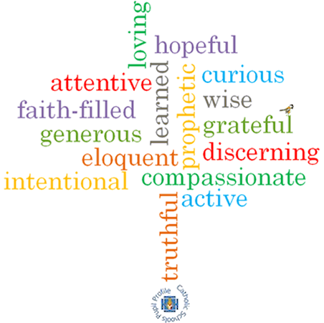

**Come and See Knowledge Organiser**

**Strand: Universal Church**

**Phase: EYFS**

**Topic: Our World**

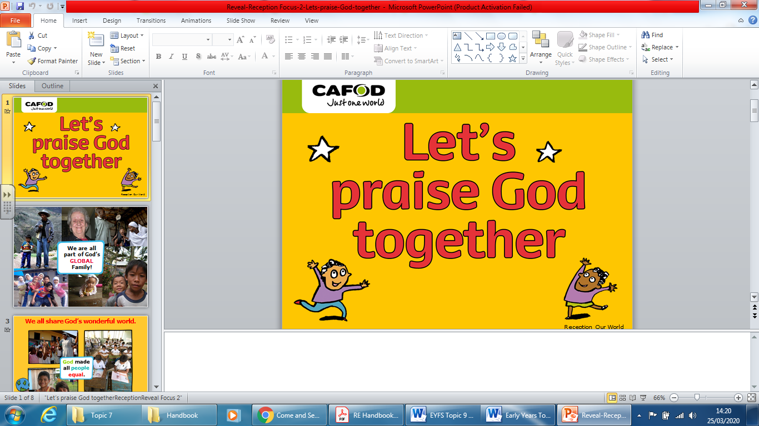

**Scripture I will hear:**

Genesis 1: 3, 9, 20, 24−26,

Psalm *God’s Story 1*

**Big Questions**

What makes our world so wonderful?

**What I will learn**

**Recognise** some words and phrases from the Psalms.

**Recognise** that people want to take care of the world and share with others because God said, “Take care of my world!”

Say what they **wonder** about the world and how we can all work together to care for the world.

**Talk about** their own experiences of the world and what they love about our world.

**What should I already know?**

We can make friends and Jesus had good friends.

**Vocabulary I will need to use**

|  |  |
| --- | --- |
| World |  |
| Wonder |  |
| wonderful |  |
| Care |  |
| Love |  |
| Share |  |
| together |  |