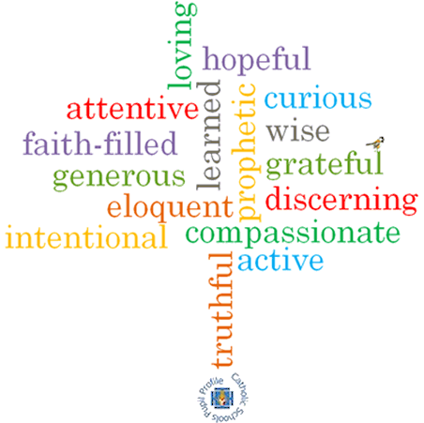

**Strand: Pentecost**

**Topic: Good News**

**Come and See Knowledge Organiser**

**Phase: EYFS**

**What I will learn**

I will begin to **talk about** how they feel when they have good news to share.

Say what they **wonder** about the joy good news brings.

Beginto **talk about** how they feel when they hear Good News.

Begin to saywhat they **wonder** about Pentecost Day and the Holy Spirit.

**Recognise** the Pentecost story as a religious story.

Use and **recognise** religious words and phrases.

**Recognise** that Christians are happy at Pentecost and go to church to celebrate the Good News.

**Vocabulary I will need to use**

Passing on the Good news of Jesus

|  |  |
| --- | --- |
| Good news |  |
| Share |  |
| Pentecost | The beginning of the church. |
| Promise | An agreement to do something |
| Holy Spirit | The spirit of God present in our lives. |
| Easter | The celebration of when Jesus died and rose from the dead. |
| Alleluia | A word to praise God. |

**Virtues**

**Scripture I will hear:**

Acts 2: 1-4

**Big Questions**

What is Good News?

Who is the Holy Spirit?

**What should I already know?**

The ways in which we grow & that Lent is a time to grow more like Jesus & look forward to Easter.