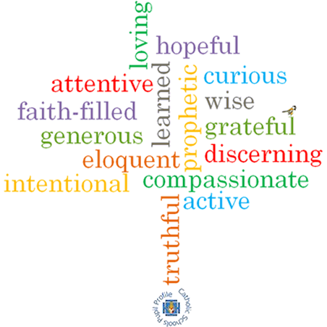

**Strand: Universal Church**

**Phase: KS1**

**Topic: Neighbours**

**Come and See Knowledge Organiser**

**Scripture I will hear:**

**Virtues**

**Big Questions**

Who is my neighbour? Why are they my neighbour? What makes a good neighbour? How can you be the best friend you can be? What is CAFOD?

**Vocabulary I will need to use**

|  |  |
| --- | --- |
| Neighbour- | Neighbour- a person living close by or who is ‘close to us’. |
| World | the planet we live on. |
| Fairtrade | where things are bought and sold in different countries for fair prices. |
| Global | around the world. |
| Family | who we are related to and love. |
|  |  |
|  |  |

**What I will learn**

**What should I already know?**