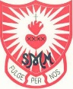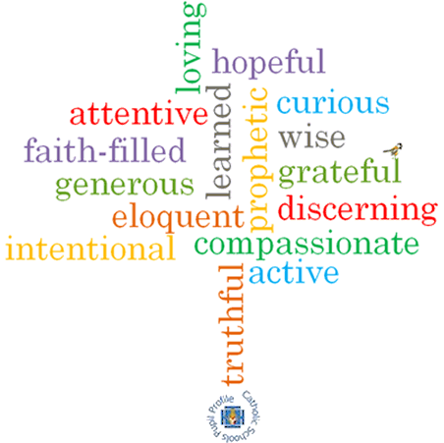

**Topic: Signs & Symbols**

**Strand: Baptism/Confirmation**

**Phase: KS1**

**Come and See Knowledge Organiser**

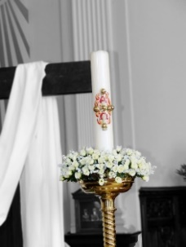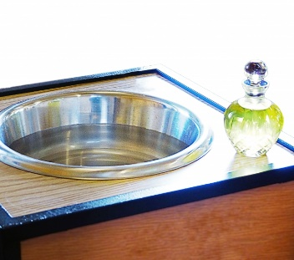

**Artefacts I will see:**

**Virtues**

**Big Questions**

How symbols have power to convey meaning.   
Why some symbols are important

How Christians maintain the light of Christ in their lives

**Vocabulary I will need to use**

|  |  |
| --- | --- |
| garment | An item of clothing. |
| Easter candle | A large candle used in Church during Easter and at Baptisms. |
| font | A bowl containing Holy water for Baptism. |
| Chrism | Oil used during Baptism. |
| Good news | Information that is positive and makes us feel happy. |
| sign | Information given to us |
| symbol | An image that gives information or represents information. |

**What I will learn**

**Talk** about their experience and feelings about signs which help them in daily life and the symbols which are important to them.

Say what they **wonder** about the meaning and importance of some symbols in their life.

**Recognise** the signs and symbols used in baptism.

**Use** some religious words and phrases used in the Sacrament of Baptism.

**Recognise** that Christians act in a particular way because they are members of the Church family.

**Ask and respond** to questions about the reasons for the importance of certain symbols in their life.

**Ask questions** about what they and others wonder about the power of symbols to convey meaning and realise that these questions are difficult to answer.

Use religious words and phrases to **describe** some actions and symbols used in baptism.

**Describe** some ways in which Christians live as followers of the Light of Christ.

**What should I already know?**

That Baptism is an invitation to belong to God’s family.