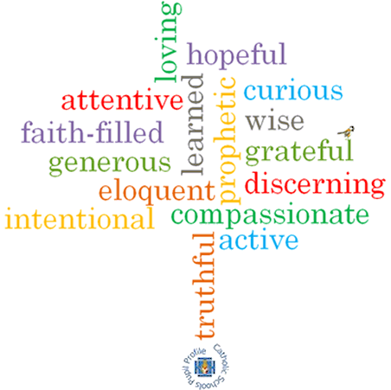

**Virtues**

**Scripture I will hear:**

**Big Questions**

Is the world a treasure?

**Topic: Treasures**

**Strand: Universal Church**

**Phase: KS1**

**Come and See Knowledge Organiser**

**Vocabulary I will need to use**

|  |  |
| --- | --- |
| treasure | Something precious to somebody, it doesn’t always cost a lot of money. |
| gift | A present |
| care | Looking after and provide for the needs of someone or something. |
| love | A feeling when you like something very much. |
| protect | Looking after something and keeping it safe from harm. |
| respect | Showing that you value something or someone. |
| Preserve creation | Taking care of what has been given to us and made by God. |
| precious | Something of great value that shouldn’t be wasted or treated carelessly. |

**What I will learn**

**Talk** about their own experience and feelings about the treasures they see or have and be able to say what they **wonder** about the treasures they see or have.

**Ask and respond** to questions about their own and others’ experiences of and feelings about what we treasure.

**Ask** questions about what they and others wonder about the treasures of our world and realise that some of these questions are difficult to answer. **Retell** some special stories about creation and the treasures of God’s world and be able to **describe** some ways in which religion is lived out by believers in the way they treasure God’s world.

**Compare** their own and others’ ideas about questions about the treasures of our world that are difficult to answer. Children will be able to **make links** between religious stories about creation/ treasuring our world and beliefs and be able to **give reasons** for certain actions by believers in relation to treasuring God’s world.

**Make links** between how they feel about their treasure and how that might affect their behaviour and that of others.

**What should I already know?**

Everyone in the world is our neighbour and is loved by God.