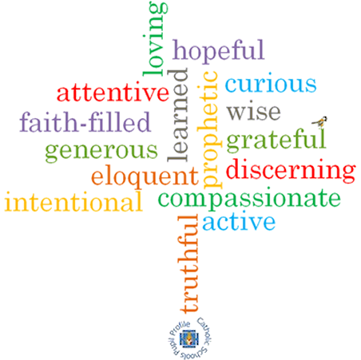

**Topic: Choices**

**Strand: Reconciliation**

**Phase: LKS2**

**Come and See Knowledge Organiser**

**What should I already know?**

The reasons for rules in the Christian family

**Big Questions**

How do we make choices?

Do all choices have consequences?

**Vocabulary I will need to use**

|  |  |
| --- | --- |
| Reconciliation | Reconciliation is the act of bringing people together to be friendly again or coming to an agreement |
| Confession | Something confessed, especially a disclosure of one's sins to a priest for absolution. |
| Penance | Penance is repentance of sins |
| Repentance | To feel remorse for; feel sorry for; be contrite about |
| Penitent | A person who repents for wrongdoing.  The word penitent means the person who is saying sorry. |
| Absolution | Freed from any question of guilt; "is absolved from all blame“  The word absolution means forgiveness |
| Grace | A persons nature to kindness and compassion  Grace is the free gift of God’s love |
| Conscience |  |
| sorrow |  |
| sin |  |
| choice |  |
| consequences |  |

**What I will learn**

**Ask and respond** to questionsabout their own and others’ experiences of making choices. **Ask questions** about what they and others wonder about how choices are made and realise that some of these questions are difficult to answer.

**Retell** the stories of the Two Sons and the Prodigal Son.

Use religious words and phrases to **describe** saying sorry and asking for forgiveness. **Describe** the Sacrament of Reconciliation.

**Describe** a simple Examination of Conscience and to write or say a sorry prayer. **Describe** some ways in which followers of Jesus live.

**Make links** to show how feelings and beliefs affect their and others’ decisions about choices and their consequences.

**Compare** their own and other people’s ideas about questions of choices and their consequences and realise that these questions are difficult to answer.

**Make links** between religious stories and the belief in a loving and forgiving God. Use a developing religious vocabularyto begin to **give reasons** for what happens in the Sacrament of Reconciliation. **Give reasons** why particular Christians make good choices and follow Jesus.

**Scripture I will hear:**

Matthew 21: 28-31

1 Thessalonians 5: 12-18

Luke 15: 11-32

**Virtues**