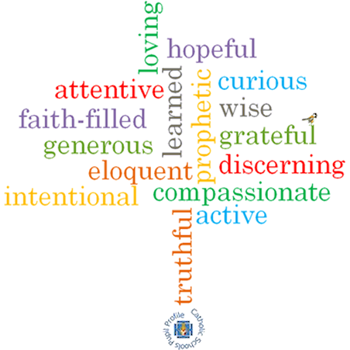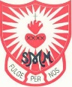

**Strand: Baptism/Confirmation**

**Phase: LKS2**

**Topic: Promises**

**Come and See Knowledge Organiser**

**What should I already know?**

Signs and symbols used in Baptism

**Big Questions**

What does it mean to make a promise?

How can we help others keep promises?

**Vocabulary I will need to use**

|  |  |
| --- | --- |
| Symbols | Something that represents or stands for something else. |
| Sacrament | A religious ceremony sharing God’s grace such as Baptism, First Holy Communion and Reconciliation. |
| Faith | Belief and trust in God. |
| Ceremonies | A formal occasion to celebrate a particular event. |
| Anointing | Smear or rub with oil. |
| Trinity | The three parts of God: God the Father; God the Son; and God Holy Spirit. |
| Commitment | Being dedicated to something. |
| Promises |  |
| rules |  |
| actions |  |
| rite |  |
| Sacrament |  |
| welcome |  |
| Church |  |
| Chrism |  |

**What I will learn**

**Ask and respond** to questions about promises.   
**Ask questions** about what they and others wonder about why people make promises.

**Retell** the story of the Baptism of Jesus.

**Describe** the actions and symbols used at Baptism.

**Make links** between their actions and the promises made.

Use a developing religious vocabularyto **give reasons** for the actions and symbols used at Baptism.

**Give reasons** for the promises made at Baptism.

**Give reasons** how and why Christians live as followers of the Light of Christ.

**Scripture I will hear:**

Jeremiah 31: 3

Mark 1: 9-11