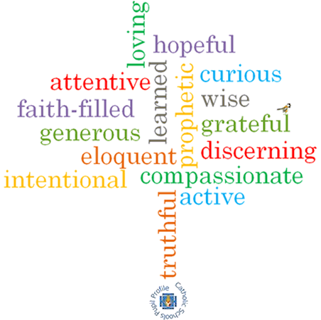

**Strand: Advent/Christmas**

**Phase: LKS2**

**Topic: Visitors**

**Come and See Knowledge Organiser**

**What should I already know?**

Advent: four weeks of preparation for the celebration of the birth of Jesus at Christmas

**Big Questions**

How visitors are welcomed

The joys and demands of visitors

**Vocabulary I will need to use**

|  |  |
| --- | --- |
| Messiah | The saviour of the people |
| Annunciation | The announcement by Angel Gabriel to the Blessed Virgin Mary that she would have a baby called Jesus by the Holy Spirit |
| Magnificat | The prayer of Mary when she goes to visit Elizabeth. |
| Isaiah | A prophet who saw the coming of Jesus Christ as the Messiah 700 years before. |
| Nativity | The birth of Jesus Christ |
| The Visitation | When Mary visited Elizabeth whilst pregnant with Jesus |
| Joyful Mysteries | The story of Mary that we can think about when we pray the Rosary |
| Joys |  |
| demands |  |
| visitors |  |
| Advent |  |

**What I will learn**

**Ask and respond** to questions about their own and others’ experiences and feelings about the events which mark the year or the season.   
**Ask questions** about what they and others wonder about how we help one another on the journey through the year.

**Retell** some of the stories of the Mysteries of the Rosary or the special feasts of the year.

Use religious words and phrases to **describe** the liturgical year and how it is composed of seasons and feasts days.

**Describe** how some prayer leads to good actions.

**Make links** to show how feelings and beliefs affect how they and others behave in their life journey and what is important to them.

**Make links** between some scripture and what Christians believe.

Use a developing religious vocabularyto begin to **give reasons** why Catholics celebrate certain feasts of the year and the reasons for the actions and symbols used.

**Scripture I will hear:**

Isaiah 11: 1

Isaiah 40: 3-5

Romans 13:9b-13a

Luke 1: 26-31, 38 -58

Luke 2: 1-20

Matthew 2: 1-12, 16-18,

**Virtues**