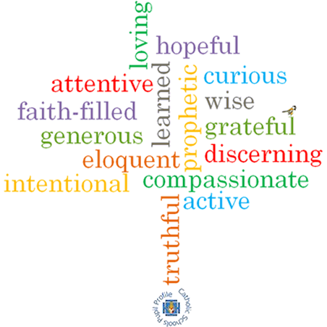

**Topic: Building bridges**

**Strand: Reconciliation**

**Phase: LKS2**

**Come and See Knowledge Organiser**

**What should I already know?**

The importance of conscience in making choices.

**Big Questions**

What might destroy a bridge of friendship?

How can bridges between people be built?

**Vocabulary I will need to use**

|  |  |
| --- | --- |
| Bridges | A structure connecting 2 points |
| friendship | A relationship between friends |
| Contrition | The state of feeling remorseful and penitent. |
| Absolution | Formal release from guilt after confession and forgiveness. |
| Sacrament of Reconciliation | A sacrament in the Catholic Church which brings us closer to God. |
| Examination of Conscience | A review of our own thoughts, words and actions for the purpose of confession. |
| sin | Actions that break God’s laws. |
| penance | Punishment inflicted on us when we have confessed to doing something wrong. |
| confession | Admitting what we have done that is wrong. |

**What I will learn**

**Ask and respond** to questions about their own and others’ experience and feelings about what breaks and what mends a friendship. Ask questions about what they and other **wonder** about how friendships may be restored. Use a developing religious vocabularyto **describe** some religious actions and symbols used in the Sacrament of Reconciliation. Use religious words and phrases to **give reasons** for some religious actions and symbols used in the Sacrament of Reconciliation.

**Make links** to show how feelings and beliefs affect their behaviour and that of others in respect to maintaining friendship. **Compare** their own and other people’s ideas about questions of building and maintaining friendship. **Make links** to show how feelings and beliefs about reconciliation affect their behaviour and that of others. **Give reasons** why believers ask forgiveness of others and forgive those who have hurt them.

**Virtues**

**Scripture I will hear:**

Colossians 3: 12-15

Matthew 5: 23-24

Luke 15:3-6,7

Mark 12: 28-31